What are the polar easterlies?

DIRECTIONS: As you read, highlight or underline the important concepts.

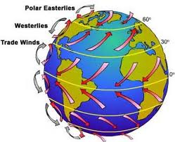
The polar easterlies are the dry, cold prevailing winds that blow from the high-pressure areas of the polar highs at the north and south poles towards low-pressure areas within the Westerlies at high latitudes.
Cold air subsides at the pole creating the high pressure, forcing a southerly (northward in the southern hemisphere) outflow of air towards the equator.
This outflow is then deflected westward by the Coriolis effect, therefore these prevailing winds blow from the east to the west.
Since the winds originate in the east, they are then known as easterlies.
Unlike the westerlies in the middle latitudes, the polar easterlies are often weak and irregular.
http://www.wfmz.com/news/What-are-the-polar-easterlies/-/121458/332756/-/t19630/-/index.html

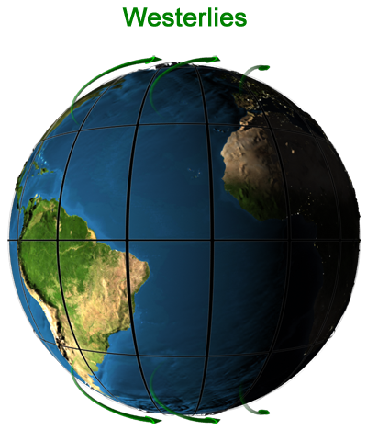
Westerlies (http://www.kidsgeo.com/geography-for-kids/0095-westerlies.php)
Above the subtropical highs in the Northern Hemisphere, and below the subtropical highs in the Southern Hemisphere, winds blow from the west towards the east. These winds are thus called westerly winds, after the direction from whence the winds come.

The prevailing westerlies are one of the five primary wind zones, known as wind belts, that comprise our atmosphere's circulatory system. They reach from where the horse latitudes leave off to approximately 60 degrees north and south latitude. The prevailing westerlies tend to be very unpredictable, but they are known to originate in the west more often than not. Wind speeds can be great in areas with few landmasses to interfere with the westerlies, especially around 40 to 50 degrees south latitude, which is nicknamed "the roaring 40s."

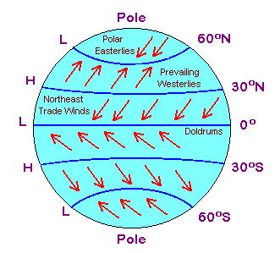
Doldrums
Sailors noticed the stillness of the rising (and not blowing) air near the equator and gave the region the depressing name "doldrums." The doldrums, usually located between 5° north and 5° south of the equator, are also known as the Intertropical Convergence Zone or ITCZ for short. The trade winds converge in the region of the ITCZ, producing convectional storms that produce some of the world's heaviest precipitation regions.
The ITCZ moves north and south of the equator depending on the season and solar energy received. The location of the ITCZ can vary as much as 40° to 45° of latitude north or south of the equator based on the pattern of land and ocean. The Intertropical Convergence Zone is also known as the Equatorial Convergence Zone or Intertropical Front.

Horse Latitudes

Between about 30° to 35° north and 30° to 35° south of the equator lies the region known as the horse latitudes or the subtropical high. This region of subsiding dry air and high pressure results in weak winds. Tradition states that sailors gave the region of the subtropical high the name "horse latitudes" because ships relying on wind power stalled; fearful of running out of food and water, sailors threw their horses and cattle overboard to save on provisions. (It's a puzzle why sailors would not have eaten the animals instead of throwing them overboard.) The Oxford English Dictionary claims the origin of the term "uncertain."
Major deserts of the world, such as the Sahara and the Great Australian Desert, lie under the high pressure of the horse latitudes.
The region is also known as the Calms of Cancer in the northern hemisphere and the Calms of Capricorn in the southern hemisphere.

Trade Winds

Blowing from the subtropical highs or horse latitudes toward the low pressure of the ITCZ are the trade winds. Named from their ability to quickly propel trading ships across the ocean, the trade winds between about 30° latitude and the equator are steady and blow about 11 to 13 miles per hour. In the Northern Hemisphere, the trade winds blow from the northeast and are known as the Northeast Trade Winds; in the Southern Hemisphere, the winds blow from the southeast and are called the Southeast Trade Winds.

Global Wind Patterns The region of Earth receiving the Sun's direct rays is the equator. Here, air is heated and rises, leaving low pressure areas behind. Moving to about thirty degrees north and south of the equator, the warm air from the equator begins to cool and sink. Between thirty degrees latitude and the equator, most of the cooling sinking air moves back to the equator. The rest of the air flows toward the poles. The air movements toward the equator are called trade winds- warm, steady breezes that blow almost continuously. The Coriolis Effect makes the trade winds appear to be curving to the west, whether they are traveling to the equator from the south or north.
The trade winds coming from the south and the north meet near the equator. These converging trade winds produce general upward winds as they are heated, so there are no steady surface winds. This area of calm is called the doldrums.
Between thirty and sixty degrees latitude, the winds that move toward the poles appear to curve to the east. Because winds are named from the direction in which they originate, these winds are called prevailing westerlies. Prevailing westerlies in the Northern Hemisphere are responsible for many of the weather movements across the United States and Canada.
At about sixty degrees latitude in both hemispheres, the prevailing westerlies join with polar easterlies to reduce upward motion. The polar easterlies form when the atmosphere over the poles cools. This cool air then sinks and spreads over the surface. As the air flows away from the poles, it is turned to the west by the Coriolis effect. Again, because these winds begin in the east, they are called easterlies. Many of these changes in wind direction are hard to visualize. Complete this exercise to see the pattern of the winds.
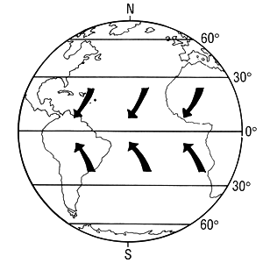

Label the Globe with Winds!

Step 1: Label the areas of high and low pressures.

Step 2: Draw with arrows the direction of the winds at that region.

Step 3: Label each type of wind with the following words (easterlies, westerlies, trade winds, doldrums)

- Questions
- What winds would Columbus have used to travel from Spain to the Caribbean?
- Which winds would he have needed to return to Europe?
- Would winds have favored European explorers seeking to travel east around the tip of Africa?
CREATE A SONG about the global winds. You must include where each of the following type of wind is found, how they are created or any unique facts about them. The song only needs to be 1 verse that contains all four winds, or you can make it a full song if you wish! Look at: https://www.youtube.com/watch?v=g4O9z_R5ZSc for an example.
-Polar Easterlies
-Westerlies
-Trade Winds
-Doldrums
Brainstorm on a separate paper and Write the FINAL lyrics here (send me the final song/or sing live by Friday):

