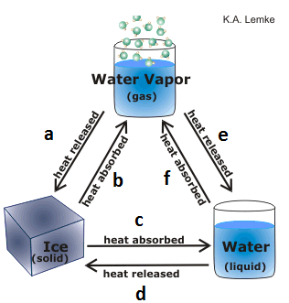
Looking at the diagram at left name the phase change that is occurring at each letter:
- ___________________________________
- ___________________________________
- ___________________________________
- ___________________________________
- ___________________________________
- ___________________________________

Use the internet or your textbook to answer the questions below.
- What term best describes water vapor? Solid, liquid, or gas circle one
- What is the difference between relative and absolute humidity? ________________________________________
__________________________________________________________________________________________
__________________________________________________________________________________________
- What are clouds made of? _____________________________________________________________________
- Describe or draw each cloud type:
Cloud | Drawing/Describe
Cumulus

Stratus

Cirrus

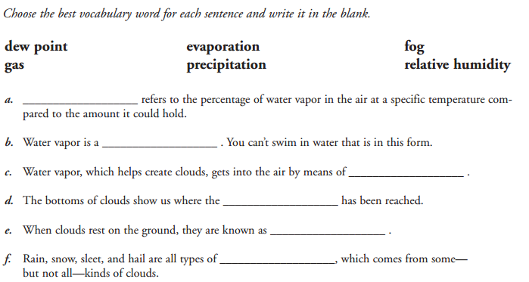
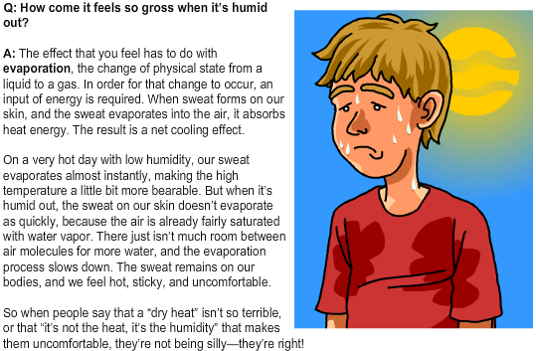
In your own words summarize what the paragraph is saying to the right. Why do you feel gross when it is humid outside?
________________________________________________________________________________________________________________________________________________________________________________________________________________________________________________________________________________________________
Cloud cover (also known as cloudiness, cloudage or cloud amount) refers to the fraction of the sky obscured by clouds when observed from a particular location. Look at the pictures below and determine the cloud cover based upon the definitions below:

SCATTERED CLOUDS -covered one quarter of the way with clouds
PARTLY CLOUDY - half with clouds
MOSTLY CLOUDY - mostly with clouds
OVERCAST - all the way covered with clouds
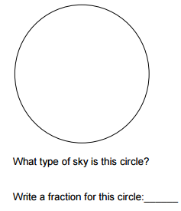
Why or why not would be difficult to determine the cloud cover of the sky? ____________________________________
__________________________________________________________________________________________________

