Volcano and Earthquake Web-Quest
Introduction
You have been chosen to help a newlywed couple decide where to buy their new house. The only problem is that they only have two choices. One is in a volcano zone and the other is on an earthquake fault! How will you help them choose? You should probably take into account how often do earthquakes and volcanoes occur. Maybe you need to determine why earthquakes and volcanoes occur. There is a lot of information you are going to need to help our newlyweds make this very important decision. Answer the following questions using the websites listed. Then, write a letter explaining to the couple which site you believe is better for them.
Earthquake Questions

Link 1: http://earthquake.usgs.gov/learn/kids/eqscience.php

1. What is an earthquake?_____________________________________________________

__________________________________________________________________________

2. What causes earthquakes and where does it form? _______________________________

__________________________________________________________________________

3. Why does earth shake when there is an earthquake? _____________________________

__________________________________________________________________________

4. How are earthquakes recorded? ______________________________________________

Link 2: http://earthquake.usgs.gov/earthquakes/index.php (Use info found on front page and “Real-time” Earthquake map)

5. Where are most earthquakes located? (Center/Edge of continents? Around which continents?)
__________________________________________________________________________

6. When and where was the earthquake with the biggest magnitude in the past 30 days? (M=magnitude). What was its magnitude?

__________________________________________________________________________

7. Which major cities in the United States are located in the earthquake zone?

__________________________________________________________________________

Link 3: http://www.scholastic.com/browse/article.jsp?id=4892

4. What is the range of magnitude for earthquakes and what scale is used to measure them?

__________________________________________________________________________

5. What happens at 1.0 scale? At 3.0? At 6.0? and 9.0? _____________________________________________________________________

Link 3: http://library.thinkquest.org/03oct/00795/earthquakecauses.html
6. What effect do earthquakes have on the surrounding area?_________________________

__________________________________________________________________________

7. Define tsunami:____________________________________________________________

8. How often can earthquakes happen?____________________________________________

Volcano Questions

Link 1: http://www.volcano.si.edu/world/find_regions.cfm

1. Where are most volcanoes found? _____________________________________________

Link 2: http://geology.com/most-dangerous-volcanoes.shtml

2. List 5 major cities in the United States which are located on or near active volcanoes

__________________________________________________________________________

Link 3: http://www.weatherwizkids.com/weather-volcano.htm

3. What is a volcano and how does it form? _______________________________________
__________________________________________________________________________

4. What are different stages of volcanoes?________________________________________

__________________________________________________________________________

5. Why do volcanoes erupt? ____________________________________________________

6. What are different types of volcanoes? ________________________________________

__________________________________________________________________________

7. How many active volcanoes are there around the world? ___________________________

8. What are some volcano safety tips? ___________________________________________

_________________________________________________________________________

Link 4: http://kids.discovery.com/games/build-play/volcano-explorer

9. (Make your own volcano) What happens when you raise viscosity but make gas level the same?
________________________________________________________________________

10. What happens to your volcano when you raise gas level but make the viscosity remain at same level?

_________________________________________________________________________

11. What happens when you raise both viscosity and gas level? _______________________

_________________________________________________________________________

Summary

1. After reviewing all of the websites, which (volcanoes or earthquakes) do you believe is more dangerous to humans? Why?

2. Do you think the couple has a higher chance of experiencing an earthquake or a volcanic eruption?

3. Do you think the couple has a higher chance of surviving an earthquake, or a volcanic eruption?

Letter:

After choosing a new home site for the couple, please write a letter explaining to the couple why you have chosen (earthquake site or volcanic site). Support your decision with at least 4 evidences from your web-quest.

Letter on following page

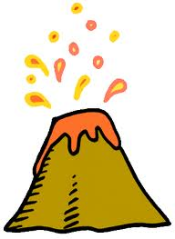
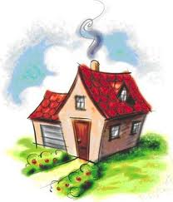
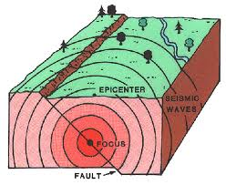
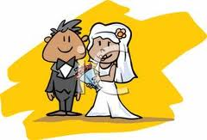

Dear Newlyweds,

Signed,

