1. Define the following terms and on the diagram to the right label the words in bold:
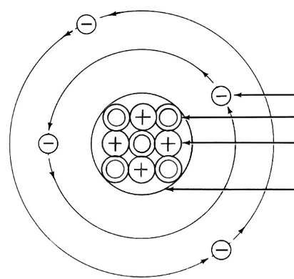
Element:
Atom:
Proton:
Neutron:
Electron:
Nucleus:

2. On your periodic table:

- Outline your metals, non - metals, and metalloids in three different colors
- Circle your noble gases
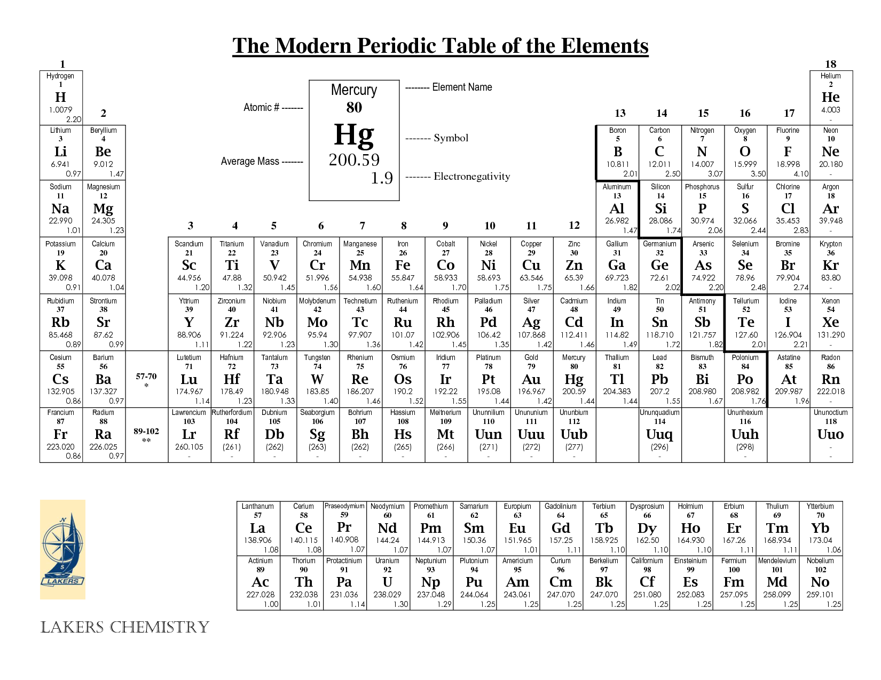
3. Define atomic number and atomic mass then look at the periodic table on your desk to complete the table on the next page.
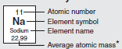
Element Name | Element Symbol | Atomic Number | Atomic Mass | Protons | Electrons | Neutrons
Beryllium
Sodium
Calcium
Silver
 | Au
 |  | 26
 |  |  | 101

4. Define Valence electrons and draw the Electron Dot Diagrams for each of the Elements below.
Valence Electrons:
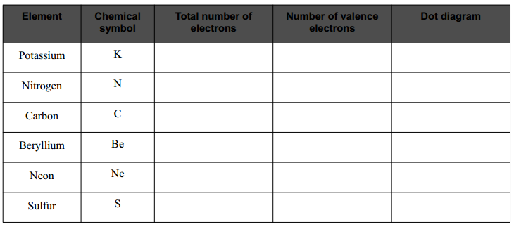
5. Why do elements bond? What are the three types of bonds?

