Unit 5B: Rocks and Minerals Name: ___________________
Define the Vocabulary:
Igneous
Extrusive Igneous
Intrusive Igneous
Mafic
Felsic
Coarse grained
Fine grained
Metamorphic
Foliated
Unfoliated
Contact metamorphism
Regional metamorphism
Sedimentary
Clastic sedimentary
Chemical sedimentary
Luster
Moh’s Scale
Density
Rock Streak
Rock cleavage
Rock Fracture
Crystal
Mineral
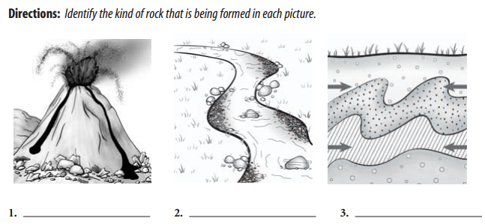
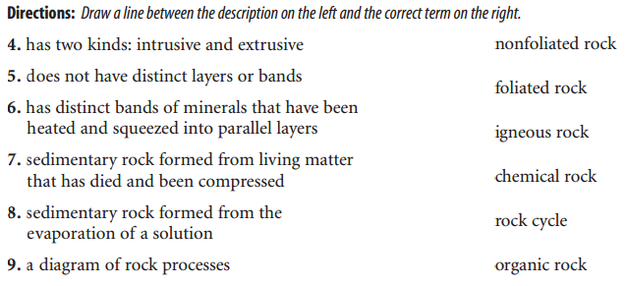
Rocks and Minerals
The ground we walk on, build on, and grow gardens on is made of rock. All the rocks in the world are made up of chemicals called minerals. Minerals are solid, inorganic (not living) substances found in and on the earth. Most are chemical compounds, which means that they are made of two or more elements. For example, the mineral sapphire is made up of aluminum and oxygen. A few minerals such as gold, silver and copper are made of a single element. Minerals are considered to be the building blocks of rocks. Rocks can be a combination of as many as six types of minerals. Through a microscope, a rock shows that it is made of crystals of different minerals, all growing together like a puzzle.

- What is the difference between a rock and a mineral?

______________________________________________________________________________

______________________________________________________________________________
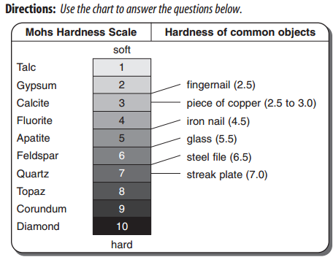’
11. Name one mineral that you can scratch with your fingernail.
12. Which mineral can scratch anything?
13. Which object can scratch feldspar but not quartz?
14. Which object can scratch apatite but not feldspar?

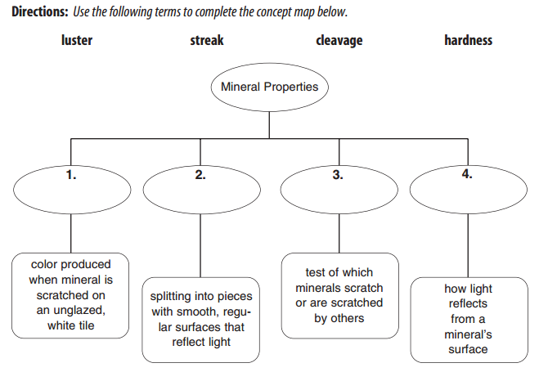

Directions: Correctly complete each sentence by underlining the better of the two choices in parentheses.

15. A mineral is an (organic/inorganic) solid material found in nature.
16. A crystal is a solid material with a (random/repeating) pattern of atoms.
17. If a mineral has (streak/cleavage) it will break in pieces with smooth, regular
surfaces.
18. A (gem/crystal) is a rare mineral, such as a diamond, that can be cut and polished.
19. A mineral is a(n) (ore/gem) if it contains something useful and can be sold for a
profit.
20. (Hardness/Specific gravity) compares the weight of a mineral with the weight of
an equal amount of water.
21. (Streak/Luster) describes how light reflects from a mineral.

Directions: Use the following terms to complete the sentences below.
magma crystal cleavage hardness
specific gravity silicates fracture luster
streak minerals gem ore
22. Halite, diamond, and graphite are examples of ____________________.
23. A(n) ____________________ is a solid in which the atoms are arranged in
repeating patterns.
24. Minerals that contain silicon (Si) and oxygen (O) are
called ____________________.
25. One of the properties of minerals is ____________________, which measures
how easily a mineral can be scratched.
26. ____________________ refers to the color left behind when a mineral is
rubbed across an unglazed porcelain plate.
27. ____________________ describes how light reflects from a mineral’s surface.
28. Amethyst is the ____________________ form of quartz.
29. Minerals that break along smooth, flat surfaces have ____________________.
30. Some crystals are formed from hot melted rock called ____________________.
31. Minerals that break with an uneven, rough, or jagged surface
have ____________________.
32. Gold’s ____________________ is 17, meaning that it is 17 times heavier than
an equal volume of water.
33. Iron is obtained from its ____________________, hematite.

Directions: Complete the concept map by writing the correct terms and phrases from the chapter next to the number
