Unit 4A: Relative Dating and Geological Time

Part A: Skills you should know

By the end of this unit, you should be able to:
-put the major time eras/periods of the earth’s history in order
-describe how each era/period is significant
-explain how relative dating is different from absolute dating
-explain how different principles of Law of Superposition, Principles of Original Horizontality & Cross-Cutting Relationships tell you which layers came first
-explain how inclusion and faults form, and their relative age to the rock layers surrounding it.

Part B: Geological Time: Use the picture to the left to help you answer the following questions.
- Order the below terms from shortest to longest amount of time by numbering them from 1 to 5. 1 is the shortest span of time and 5 is the longest span of time.

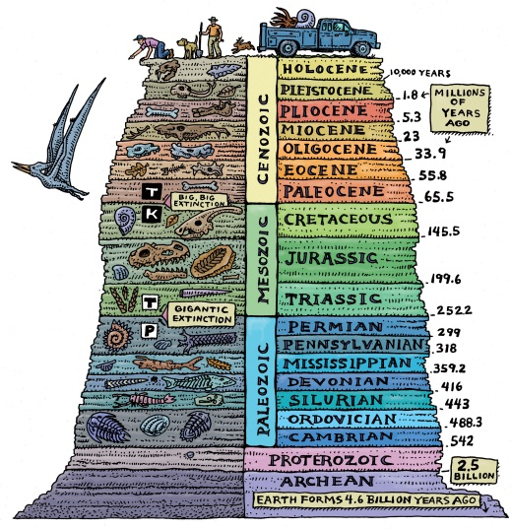
Age Period Era Eon Epoch

2. Name the largest time span of the earth’s history | 3.How long ago did Precambrian start? | 4. Time span when bacteria begin to form | 5. Time span when hard-shelled organisms begin to form
6. known as period of fish | 7. what organisms were most common during Paleozoic era? | 8.what organisms were most common during Mesozoic era? | 9. which era is known as the era of mammals?  10. What time period do we live in?

- For each of the below periods illustrate what major species emerged and the era the period is included in. The first one is done for you.
Era | Period | New Major Species
Mesozoic | Jurassic
 | Quaternary
 | Triassic
 | Cambrian
 | Denovian

Part C: Relative Dating Vocabulary Words
Define the following vocabulary words. Then, illustrate an example of each of the words.

Relative Dating  Definitions:  Illustration: | Absolute Dating  Definitions:  Illustration: | Law of Superposition,  Definitions:  Illustration:
Principle of Cross-Cutting  Definitions:  Illustration: | Principles of Original Horizontality  Definitions:  Illustration: | unconformity  Definitions:  Illustration:
Dike  Definitions:  Illustration: | Fault  Definitions:  Illustration: | Inclusion  Definitions:  Illustration:
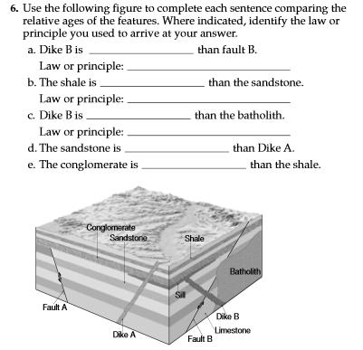
Part D: Applying concepts
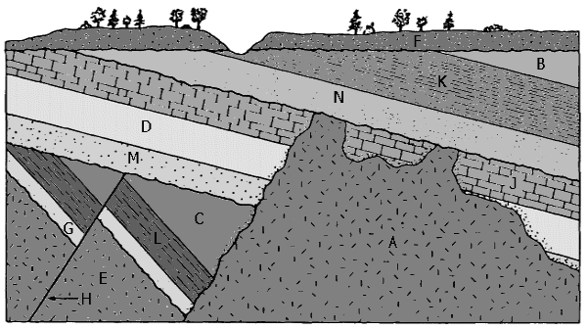

For the above picture order the layers from youngest to oldest

___________________________________________

___________________________________________

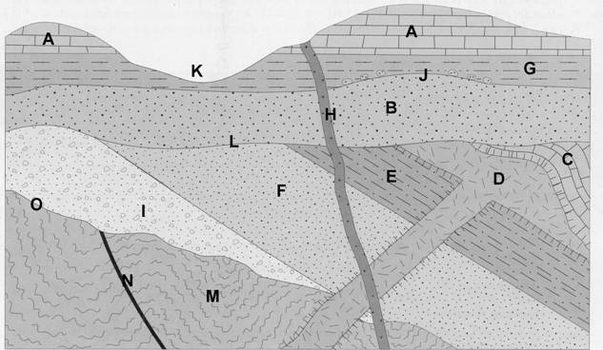
For the above picture order the layers from youngest to oldest

___________________________________________

___________________________________________

