Unit 3 B: Plate Interactions and Earthquakes
Vocabulary:
Plate:
Lithosphere:
Asthenosphere:
Convection Currents:
Convergent:
Divergent:
Transform:
Earthquake:
Focus:
Epicenter:
Fault Line:
S wave:
P wave:
Landslide:
Liquifaction:
Tsunami:
Mercalli Scale:
Richter Scale:

Plates and plate interactions
- On the below picture mark with an x which layer makes up plates.
- On the below picture mark with a y which layer is responsible for the movement of plates.
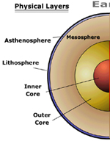
- What are convection currents and how do they aid in the movement of plates? Draw a picture of the motion of convection currents.
_______________________________________________________________________________________________________________________________________________________________________________________
Convection Current picture:

- For each of the pictures below state which plate interaction is occurring (convergent, divergent, transform) and what is the result of this plate interaction. 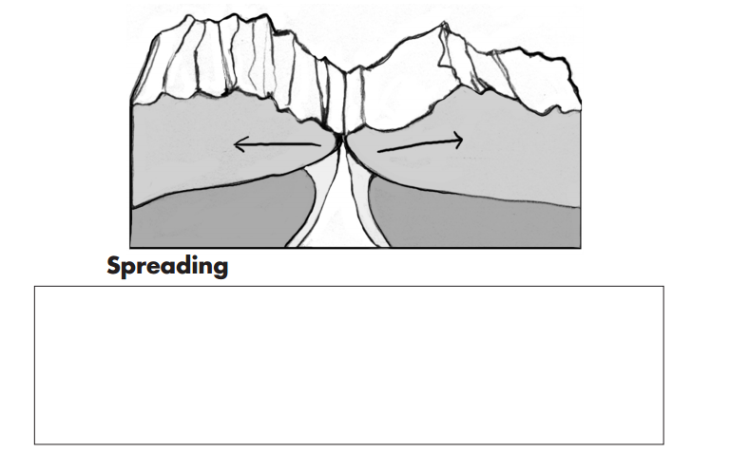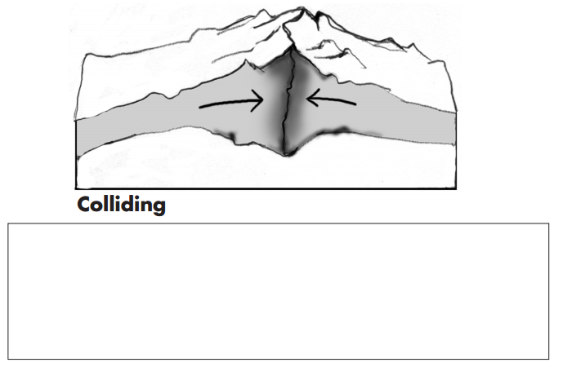
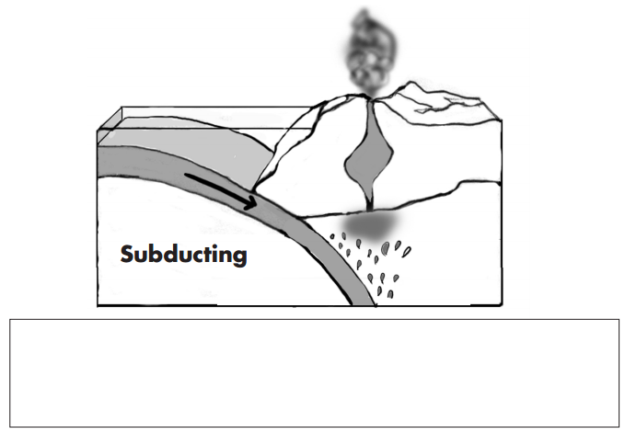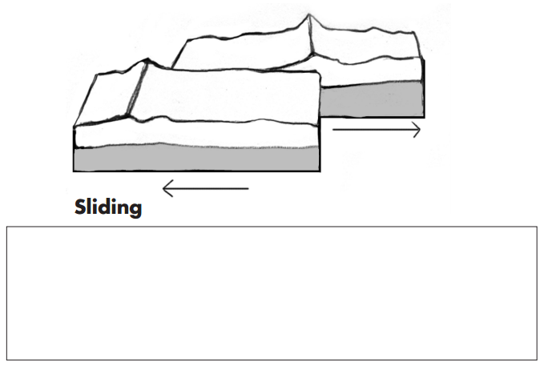

- Complete the Table based upon the data analysis questions.
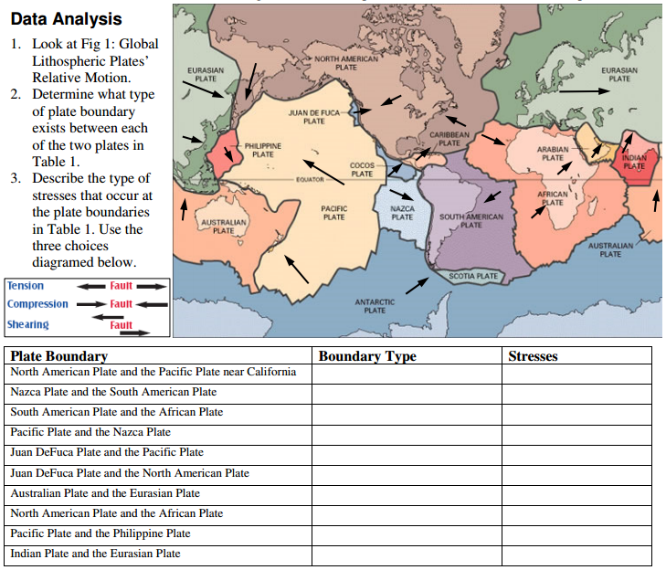

Earthquakes
Label the following parts (focus, epicenter, and fault) in the picture below:
