Unit 3 A: Parts of the Earth and Plates
Vocabulary Name:__________________
Physical layers of the Earth:
Compositional layers of the Earth:
Asthenosphere:
Mesosphere:
Lithosphere:
Inner Core:
Outer Core:
Geosphere:
Atmosphere:
Hydrosphere:
Biosphere:
Mantle:
Oceanic Crust:
Continental Crust:
Plate:
Continental Drift:
Plate tectonics:

Compositional of the Earth
Correctly draw and label the compositional layers of Earth (Core, Crust, and Mantle) and state what elements make up each layer.

Which compositional layer is mostly iron and nickel? ____________________________________
Physical Layers of the Earth
Correctly draw and label the physical layers of Earth (Asthenosphere, Lithosphere, Mesosphere, Inner Core, and Outer Core) and state where each layer is a solid, liquid, or gas.

Which physical layer is the only liquid layer? _________________________________
Which physical layer is considered a plastic like solid? __________________________
There are four spheres of the Earth. What are the names of the four spheres? ________________, ________________, ________________, ________________
For each of the below sections, identify which sphere the picture is representing.
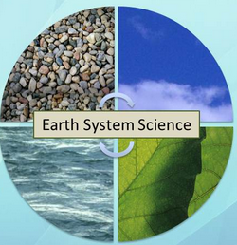
Create your own diagram for the spheres using different pictures then the ones above.

Plate Tectonics
Give 3 pieces evidence for Charles Wegner’s theory of continental drift? _______________________________________________________________________________________________________________________________________________________________________
Why was Charles Wegner partially wrong? _____________________________________________________________________________________
What evidence is there for plate tectonics?
_______________________________________________________________________________________________________________________________________________________________________
What is paleomagnetism? ____________________________________________________________
What were are two types of plates? ____________________________________________________
Which plate type has a greater density? _________________________________________________

