Unit 2: Formation of the Earth and Universe Signature of Teacher:______________________

Vocabulary:
Theory
Hypothesis
Law
Big Bang Theory
Nebular Hypothesis

Skills:
- Differentiate between a theory and a hypothesis
- Be able to describe the Big Bang theory and its significance
- Be able to describe the nebular hypothesis and its significance
- Know the steps involved in the formation of the Earth

Theory vs. Hypothesis

How is a theory different from a hypothesis?
__________________________________________________________________________________________________________________________________________________________________________
How can a hypothesis become a theory?
__________________________________________________________________________________________________________________________________________________________________________
How can a theory become a law?
__________________________________________________________________________________________________________________________________________________________________________

Big Bang Theory

Describe what the Big Bang Theory states and illustrate it in the box below.
_______________________________________________________________________________________________________________________________________________________________________________________________________________________________________________________________

Big Bang Theory illustration:

Nebular Hypothesis
Use the below pictures to help you describe the steps of the nebular hypothesis.

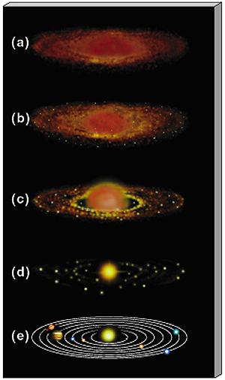
(d)
________________________________________________________________________________________________________________

(c)
________________________________________________________________________________________________________________

(b)
________________________________________________________________________________________________________________

(a)
________________________________________________________________________________________________________________

Formation of the Earth
Use the following website to help you fill in the blanks below: http://easyscienceforkids.com/all-about-how-the-earth-was-formed/
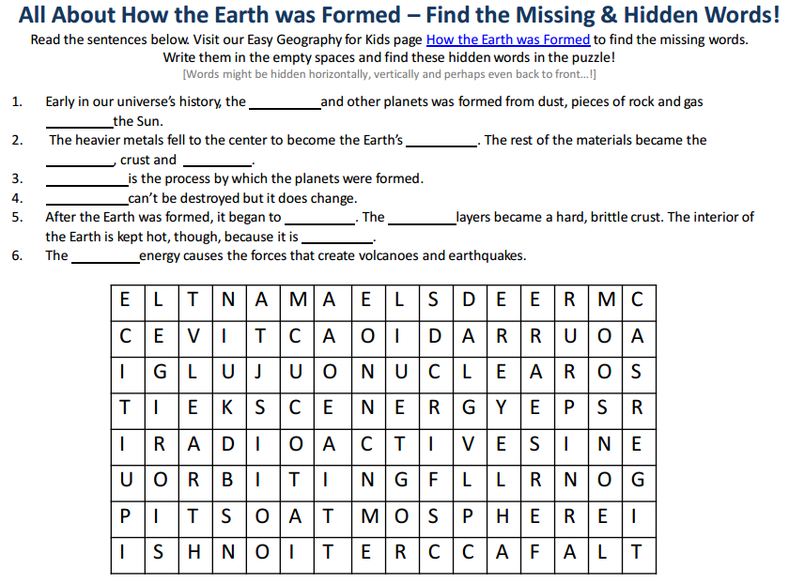

What caused the oceans of the Earth to form?
__________________________________________________________________________________________________________________________________________________________________________
What was the original atmosphere on the Earth like?
__________________________________________________________________________________________________________________________________________________________________________
How was the inner core of the Earth formed? What does the core’s formation have to do with density?
__________________________________________________________________________________________________________________________________________________________________________
__________________________________________________________________________________________________________________________________________________________________________
In your own words, write how the Earth developed from dust circling the sun to the ocean and forest covered oxygen rich plant it is today.
__________________________________________________________________________________________________________________________________________________________________________
__________________________________________________________________________________________________________________________________________________________________________
__________________________________________________________________________________________________________________________________________________________________________

