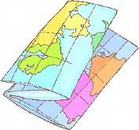
A scale is the _________________________ between two sets of measurements.
A scale helps us take real life distances and measurements and show them in a much smaller space.

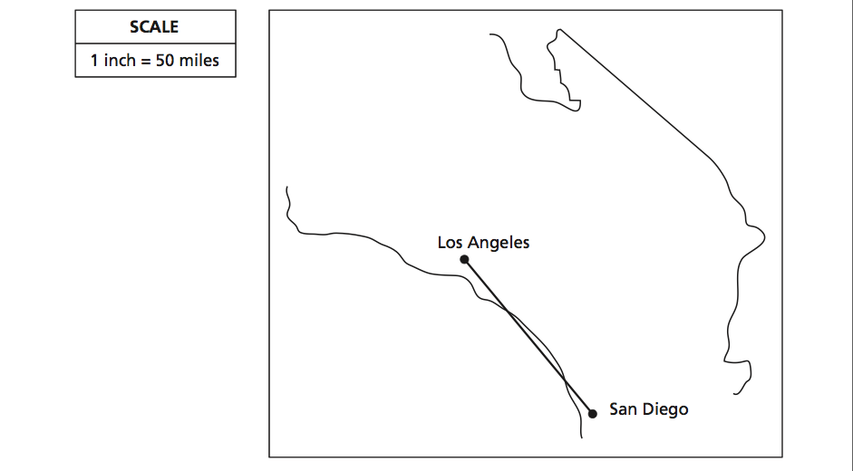 | Based on the scale, what is the distance, in miles, between the two cities?  Show your work.
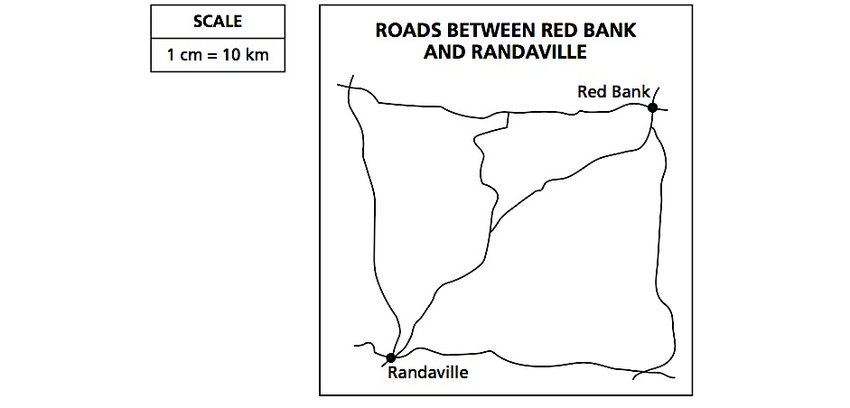 | What is the distance of the most direct route between Red Bank and Randaville?
C. Maria is planning a car trip from Niagara Falls to East Aurora.
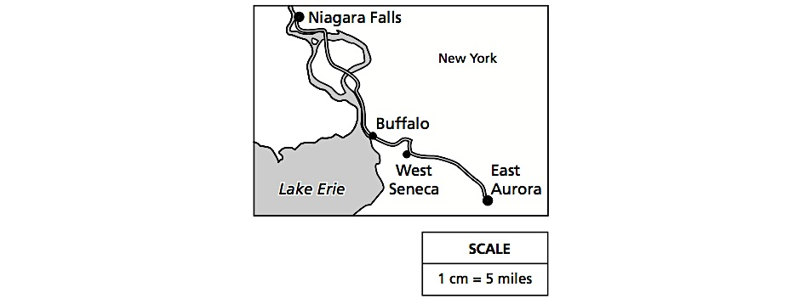

What is the approximate driving distance from Niagara Falls to East Aurora?
The map scale is 1 in : 50 mi. Find the distance between each pair of cities (show all calculation)

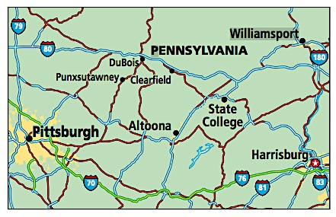
- Pittsburgh and Altoona

- Pittsburgh and Punxsutawney

- Altoona and State College

- DuBois and Clearfield

- State College and Harrisburg

Use the map below to find the distance between two locations indicated. Use the key provided to in the map. Show all work.

a. Alpharetta high school Publix b. Post OfficePark

c. Alpharetta High school Starbucks d. Starbucks Village Tavern

