**Purpose:** To learn to make a topographic map

**Background Information:** A topographic map is often a large scale map that shows the shape of the land’s surface. **Contour lines** are imaginary lines that connect places of equal elevation. If you were taking a hike along a hillside and not walking either unhill or downhill, you would be walking on a contour line. When contour lines are close together, the slope is very steep. When contour lines are far apart, the slope is very shallow. This type of map is helpful when planning a hike. It is also used when planning the site for a building or the path of a new road. Contour lines are sometimes called “level lines” because they show points that are at the same level. Here’s how contour lines work:

**Pre-Lab:**

The top of the drawing is a a contour map showing the hills that are illustrated at the bottom. On this

map, the vertical distance between each contour line is 10 feet.



1. Which is higher, hill A or B?

2. Which is steeper, hill A of B?

3. How many feet of elevation are there between contour lines?

4. How high is hill A?

5. How high is hill B?

6. Are the contour lines closer together on hill A or hill B? What does that mean?

**Materials:**

Plastic Bin Volcano Model Expo Marker

Plastic Lid Ruler Beaker of Water

**Procedures:**

1. Place volcano model within plastic bin and close the lid.
2. Using your ruler and expo marker, mark every 1 cm along the side of the plastic bin.
3. Use your expo marker to trace on the lid the perimeter of volcano model, this will be your starting elevation of 6000 ft above sea level.
4. Add water to the 1 cm mark. Using your expo marker, trace on your lid where the water touches the volcano model.

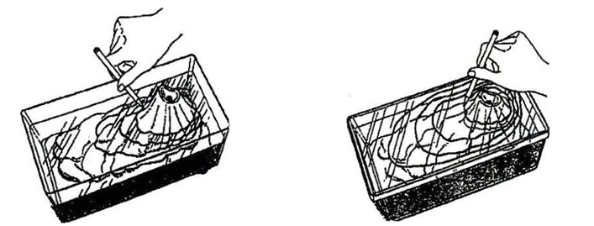

1. Repeat step 4 at each centimeter mark, until the volcano is completely covered.
2. Pour the water back into the beaker.
3. Place the last page of the lab over the lid, and trace the contour lines onto your paper. It may be helpful to place in front of a light source.
4. Wipe the expo marker off of the plastic bin and lid. Wipe up any water left on the table.
5. Mark on your map the elevation levels. Each cm = 500 ft. Label your map with the name of your volcano.

**Conclusion:**

1. Describe the general shape of your contour lines. (Perfect circles? Straight lines?)

____________________________________________________________________________

____________________________________________________________________________

1. How would you describe the steepness of slope? How do your contour lines support this?

____________________________________________________________________________

____________________________________________________________________________

____________________________________________________________________________

____________________________________________________________________________

1. Why a topographic or contour map is a useful tool to have?

____________________________________________________________________________

____________________________________________________________________________

____________________________________________________________________________

Use this paper to draw your topographic map.

