Objective: To discover how the atmosphere can be divided into layers based on temperature changes at different heights, by making a graph.
Background: The atmosphere can be divided into four main layers based on temperature variations. The layer closest to the Earth is called the troposphere. Above this layer is the stratosphere, followed by the mesosphere, then the thermosphere. Temperature variations in the four layers are due to the way solar energy is absorbed as it moves downward through the atmosphere. The Earth’s surface is the primary absorber of solar energy. The Earth as heat, which warms the overlying troposphere, reradiates some of this energy. The global average temperature in the troposphere rapidly decreases with altitude until the troposphere ends and changes to the stratosphere. The temperature begins to increase with altitude in the stratosphere. This warming is caused by a form of oxygen called ozone (O3), which absorbs ultraviolet radiation from the sun. Ozone protects us from most of the sun’s ultraviolet radiation, which can cause cancer, genetic mutations, and sunburn. Scientists are concerned that human activity is contributing to an increase in stratospheric ozone. Nitric oxide, which is the exhaust of high-flying jets, and chlorofluorocarbons (CFC’s), which are used as refrigerants, may contribute to ozone depletion and global warming. Ozone found in the troposphere is considered a pollutant. The overlying mesosphere does not absorb solar radiation, so the temperature decreases with altitude. This is the coldest layer of the atmosphere, nearing –90˚ C. In fact it is colder then Antarctica’s lowest recorded temperature and can even freeze water vapor. The farthest main layer from us is the thermosphere. The thermosphere is divided into 2 layers: the ionosphere and the exosphere. Each of these layers has their own characteristics. The ionosphere contains charged particles, which produces the Aurora Borealis (Northern Lights) and the Aurora Australis (Southern Lights). The exosphere has air molecules that are very spread out and is considered to be very thin. The international space station orbits the Earth within the thermosphere between 200-240 miles or 320-380 kilometers. NASA considers 62 miles or 100 kilometers to be the beginning of space.
Directions:
- The table contains the average temperature readings at various altitudes in the Earth’s atmosphere. Plot this data on the graph and connect the points with a smooth curve. (Be careful to plot the negative temperature numbers correctly)
- Data: Table 1 - Average Temperature Readings at Various Altitudes
Temp (⁰C) | Altitude (km) |  | Temp (⁰C) | Altitude (km)
15 | 0 |  | -2 | 52
-18 | 5 |  | -7 | 55
-49 | 10 |  | -17 | 60
-56 | 12 |  | -33 | 65
-56 | 20 |  | -54 | 70
-51 | 25 |  | -65 | 75
-46 | 30 |  | -79 | 80
-37 | 35 |  | -86 | 84
-22 | 40 |  | -86 | 92
-8 | 45 |  | -81 | 95
-2 | 48 |  | -72 | 100

- Mark the separation of the layers of the atmosphere with a colored line and label each section with the layer name.
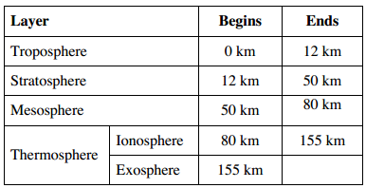
- Draw and color the below pictures on your graph to represent their location:
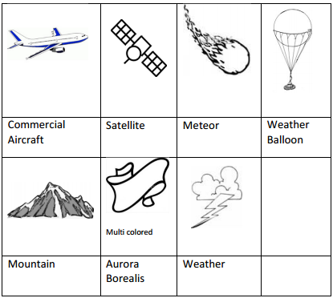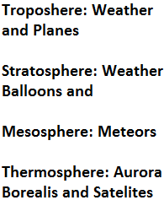
Questions (Answer based upon your graph and the paragraph in the front):

- What is the basis for dividing the atmosphere into four layers? _________________________________________________
_____________________________________________________________________________________________________

- Does the temperature increase or decrease with altitude in the:

troposphere? _____________ stratosphere? ________________

mesosphere? _____________ thermosphere? _______________

- What causes the temperature to increase with height through the stratosphere, and decrease with height through the mesosphere? _________________________________________________________________________________________
_____________________________________________________________________________________________________
_____________________________________________________________________________________________________
- What causes the temperature to decrease with height in the troposphere?
_____________________________________________________________________________________________________

- What layer of the atmosphere do you think is of greatest interest to meteorologist? ___________ _____________________

- Match the following descriptions with the layer in which it belongs.

a. Closest layer to the Earth _______________________ b. Has rain clouds _______________________
c. Where we live _______________________ d. Has a great deal of ozone _______________________
e. Has the coldest temperature _______________________ f. Has a layer of ions _______________________
g. Reflects radio signals _______________________ h. Meteors generally burn up _______________________

Graph: Temperature vs Altitude of the Layers of the Atmosphere
100

95

90

85

80

75

70

65

60

55

50

45

40

35

30

25

20

15

10

5

0
Altitude (km above sea level)
-100 -90 -80 -70 -60 -50 -40 -30 -20 -10 -5 0 10 20

Temperature (⁰C)

Atmospheric Gases
Purpose:
To graph the percentage of various gases found in the atmosphere.
Data:
The air in the atmosphere is a mixture of many gases as shown in the data table below.
Gas | Percent by Volume (%) | Degrees (= % x 360)
Nitrogen | 78
Oxygen | 21
Argon | 0.93
Carbon Dioxide | 0.03
Ozone | 0.0006
Neon | 0.0018
Helium | 0.0005
Hydrogen | 0.00005
Other Gases | 0.00005
Procedure:
- Create a pie graph using a protractor illustrating the composition of gases in the atmosphere.
- Use different colors to represent each type of gas in your graph. Color the answer with the corresponding colors on your key.
Pie Graph:
Key:
Nitrogen –
Oxygen –
Argon –
Carbon dioxide –
Ozone –
Neon –
Helium –
Hydrogen –
Other Gases –

Questions:
- Which gas makes up the greatest percentage of gas in the atmosphere? ____________________

- Which gases are involved in the respiration cycle and what percentage of the atmosphere are they? ________________________________________________________________________________________________________

