Directions: Use your notes to fill out the charts below.

Physical Layers of the earth | Prefix meaning | Physical Characteristics | other characteristics
Lithosphere
Asthenosphere
Mesosphere
outer core
inner core
Earth’s Layer by compound | thickness | compounds | other characteristics
crust
mantle
core

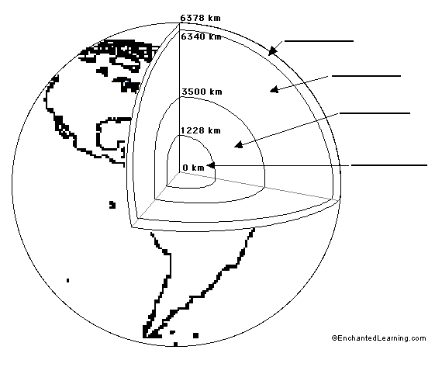

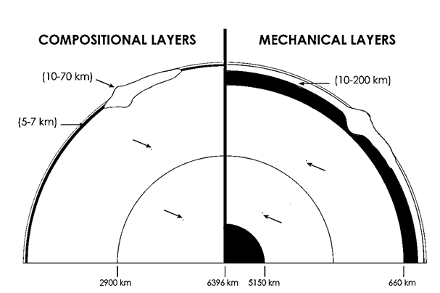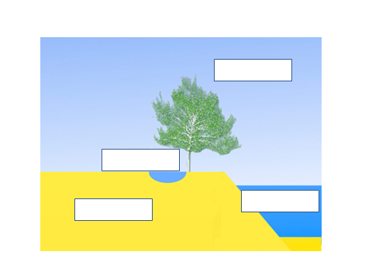
Earth’s Spheres & Layers

Earth’s spheres | Prefix meaning | characteristics
hydrosphere
biosphere
atmosphere
geosphere

Directions: For each of the “circles” write a name of a sphere and illustrate each of the “sphere” in the circle (must color them)

