Real Life Application: Humidity and Heat measuring saves lives
The 2013 Annual Football Survey stated that 52 football players have died from heat stroke since 1995. In the last ten year there were 31 deaths and most occurred during practice. Due to this each state has created guidelines for football coaches to follow when conducting practice to ensure a same environment. Georgia’s policy is listed below:
“Schools must follow the statewide policy for conducting practices and voluntary conditioning workouts (including during the summer) in all sports during times of extremely high heat and/or humidity. A scientifically-approved instrument that measures the Wet Bulb Globe Temperature must be utilized at each practice to ensure that the written policy is being followed properly. WBGT readings should be taken every hour, beginning 30 minutes before the beginning of practice.” – www.ghsa.net
We don’t have the instrument the football coaches use. However, you will determine if it is safe enough to practice football using the tools you created in class. Below is the equation for determining the Wet Bulb Globe Temperate and the table to determine if it’s safe to play. Use your tools and then advise if it is safe to play or not.
- T_{w} = Natural wet-bulb temperature (combined with dry-bulb temperature indicates humidity)
- T_{g} = Globe thermometer temperature (measured with a globe thermometer, also known as a black globe thermometer)
- T_{d} = Dry-bulb temperature (actual air temperature)
- Temperatures may be in either Celsius or Fahrenheit
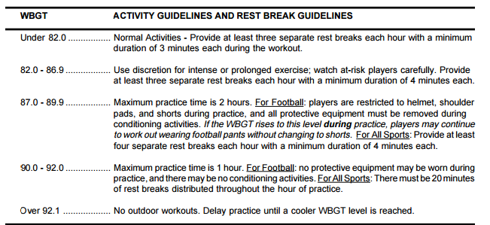
What instruments will you use to determine the WBGT?
Show you recorded data and calculations below?
What would you advise the football coach?

