Go to http://conhs.gcumedia.com/phy104/geologicalTime.html
- Click on each time slide and define the terms below as you see them in the slides. Make sure you watch each video to see how the layers were formed.
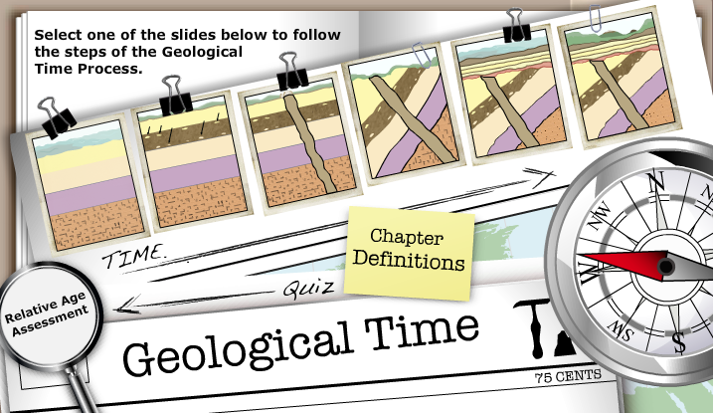
Definitions
Word | Definition
Principle of Superposition
Principle of Original Hirizontality
Principle of Lateral Continuity
Law of Cross-Cutting Relationships
Principle of Inclusion
Principle of Faunal Succession
Unconformities
Disconformity
Angular Unconformity
Nonconformity
Correlation

- Click on Relative Age Assesment and put your answers in the boxes provided.
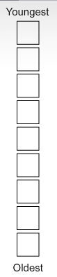
- Make sure you understand everything because you will be taking a pop quiz later.
- Go to: http://www.nationalgeographic.com/seamonsters/virtualdig/index.html
There are three digging site. Identify the fossil uncovered at each site:
Site 1 fossil: ________________________
Site 2 fossil: ________________________
Site 3 fossil: ________________________

- Click on the interactive timeline tab or go to: http://www.nationalgeographic.com/seamonsters/timeline/index.html
List the four time periods that are shown on the interactive timeline and write a brief description of each time period.
1._____________________________________________________________________________________________________________________________________________________
2._____________________________________________________________________________________________________________________________________________________
3._____________________________________________________________________________________________________________________________________________________
4._____________________________________________________________________________________________________________________________________________________
6. Look at question the three fossils you uncovered in question 4 and determine what time period each of them came from:
Site 1 fossil time period: ________________________
Site 2 fossil time period: ________________________
Site 3 fossil time period: ________________________

