Formation of the Earth & Representing the Earth Review

Part A: Short Answers:

1.(3pts) What is the theory that describes how the UNIVERSE was formed called? _________________. Briefly explain what this theory states.

2. (3pts) What is the hypothesis that describes how the SOLAR SYSTEM was formed called? _________________. Briefly explain what this hypothesis states.

Part B: Use the word bank below to fill in the blanks. Some words may repeat. NOT ALL WORDS will be used.

latitude | longitude | prime meridian | equator | 0⁰ | 90⁰
scale | map | key | globe | atmosphere | hydrosphere

3. _____________________is the main line of longitude. From here, the east and west is divided up into smaller degrees.

4. ___________________is the main line of latitude. From here, north and south is divided up into smaller degrees.

5. ____________________lines run from east to west. They measure the distances of north and south of the equator.

6. The equator’s location is at exactly ____________.

7. The prime meridian’s location is at exactly _______________.

8. A _____________tells the ratio of the distance on the map compared to the real distance.

9. The ______________tells you the landmarks or any other important locations on a map.

10. A ______________is a graphic representation of the earth’s surface drawn to scale.

Part C:

11. (2pts) A map’s scale says 1mm: 1 meters. When you measure the distance between Atlanta and Charlotte on the map, you get 400mm. Calculate what the distance is in real life, and show all of your work. Circle your answer (with proper units!)

12 (2pts) On the map, the distance between Atlanta and Disney world is 6cm. If the map’s scale is represented in the ratio of 1cm= 200km, what is the actual distance between Atlanta and Disney world? Show all work below:

13. Use the map below to answer the following questions:

a. Which city is present at 34ºN and 84ºW?

b. Write the proper coordinates for New Orleans.

c. Write the proper coordinates for Denver.

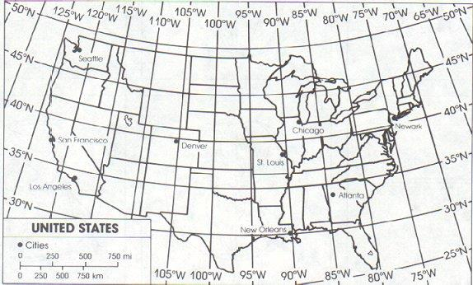

14. Name the 4 spheres of the earth.

15. Name the 3 compound layers of the earth.

16. Names the 5 physical/mechanical layers of the earth.

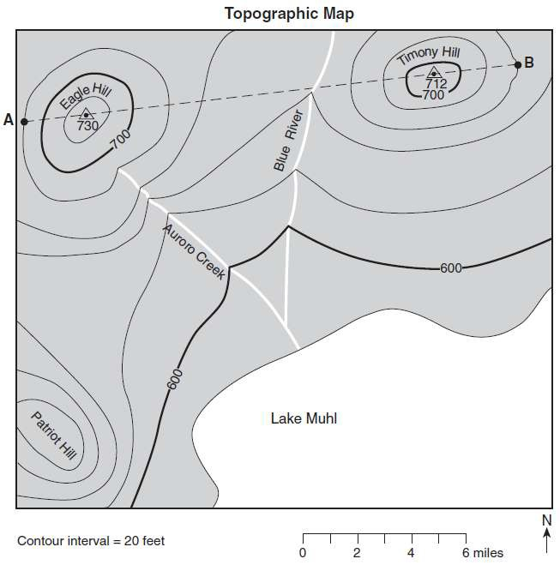
17. What is the contour interval of the above map?

18. What is the elevation at point A?

19. What is the elevation at point B?

20. What is the difference in elevation from point A to point B?

Vocabulary:
International system of units (SI)
Scientific method
Hypothesis
Independent variables
Dependent variables
Control
Constant
Theory
Law
Earth Science
Nebular hypothesis
Solar system
Big Bang Theory
Biosphere
Hydrosphere
Geosphere
Atmosphere
Compound layers
Physical layers
Core
Mantle
Crust
Lithosphere
Asthenosphere
Mesosphere
Outer core
Inner core
Map
Latitude
Longitude
Prime meridian
Equator
Scale
Key (map)
Topographical map
Contour lines

