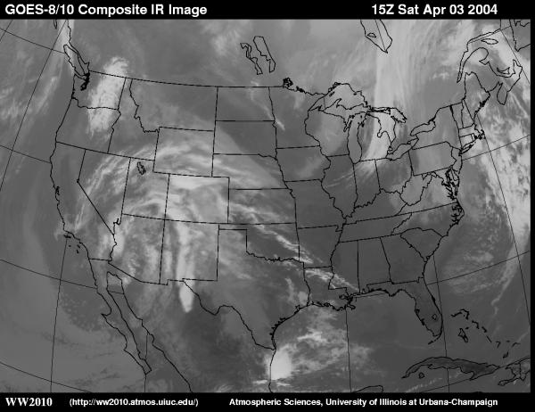
Forecasting the Weather Web Quest

Based on the Internet Web site WW2010 by The University of Illinois

http://ww2010.atmos.uiuc.edu/(Gh)/home.rxml

Introduction: How do meteorologists forecast the weather? In this web quest we will explore air masses, fronts, weather stations and weather forecasts.
Procedure: Follow the links for each question and write down your responses on this sheet.
Q# | Link & Question | Answer
 | http://tinyurl.com/ygqof6
 | What is an air mass?
 | http://tinyurl.com/zyvrhuh
 | Describe the temperature, moisture and air pressure associated with a Continental Polar air mass.
 | http://tinyurl.com/mxy2v3y
 | Describe the temperature, moisture and air pressure associated with a Maritime Tropical air mass.
 | http://tinyurl.com/zukyxau
 | Describe a high pressure center. What is another name for a center of high pressure?
 | http://tinyurl.com/zpoehay
 | What is a cyclone? What direction do winds flow in cyclones in the Northern Hemisphere? In the Southern Hemisphere?
 | http://tinyurl.com/juavghz
 | Watch this animation on how winds flow around cyclones (pressure lows) and anticyclones (pressure highs) in the Northern Hemisphere. Draw and describe what you observe below.
 | http://tinyurl.com/a4uz
 | What is the definition of a front?
8. | http://tinyurl.com/jb66mwd
 | Individual surface weather stations use a standard format to report date. Review the weather stations symbols for temperature, weather symbol, dew point, cloud cover, sea level pressure and wind. Draw and label the station symbol in this example.
9. | http://tinyurl.com/3ykt9ye
 | What is a cold front? Describe the characteristics before, during and after a cold front below.
10. | http://tinyurl.com/ljkrzne
 | Watch the animation of a cold front and describe the type of precipitation associated with cold front movement.
11. | http://tinyurl.com/9ewqm
 | What is a warm front? Describe the characteristics before, during and after a cold front below.
12. | http://tinyurl.com/n7ytrrs
 | Watch the animation of a warm front and describe the type of precipitation associated with a warm front.
13. | http://tinyurl.com/h6rov8s
 | What factors lead to an increased probability (chance) of precipitation?
14. | http://tinyurl.com/hsluzqy
 | Explain the importance of temperature in the formation of rain, freezing rain, sleet or snow. (What forms at which temperatures?)
 | http://tinyurl.com/zmuqlk4
 | What is a Supercell Storm? What dangerous conditions may develop during supercell storms? What wind and cloud conditions are prevalent in supercell storms?
 | http://tinyurl.com/jaxv9cs
 | What is the “Jet Stream” and at what altitude is the jet stream measured?
 | What are the “major factors” that a meteorologist need to consider (or measure) to forecast weather? How do you think we can increase the accuracy of weather forecasting? (Explain thoroughly in details).

