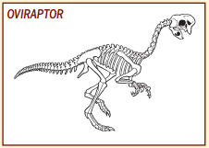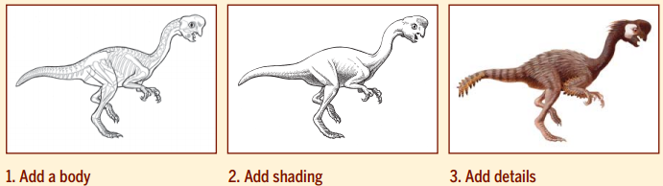
Follow the steps to flesh out this Velociraptor skeleton.

Give it a pet name:______________________________________________

