El Nino and La Nina
Directions: Explore the 3 sites below and answer the questions below:

A) http://tinyurl.com/87llwtu

B) http://tinyurl.com/j7378na
C) National Geographic: http://tinyurl.com/lmpxoux
1. What is El Niño?
2. Do scientists know what is causing El Niño?
3. Why is El Niño an interpretation of the “the Christ Child”?
4. How often does El Niño occur?
5. Describe upwelling and its importance:
6. What is the difference between El Niño and La Niña? Fill in the prompts below:
Normal | El Niño – Warmer Waters | La Niña-Colder Waters
Which areas of the world do these patterns originate?
Wind Direction

Water movement

How is upwelling a factor in these 2 weather patterns?

Describe how living organisms are affected.

How is the economy affected by these weather patterns?

Overall
Weather impacts:

Overall Weather Changes:

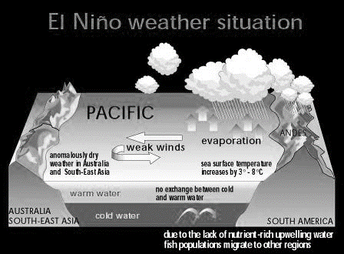
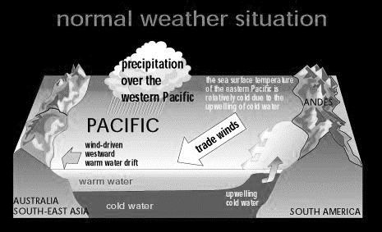
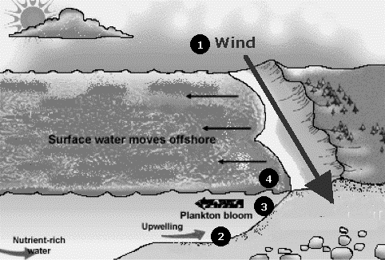
Ocean Upwelling

Answer Key.

Normal | El Nino – Warmer Waters | La Nina-Colder Waters
Normal ocean shore upwelling in Pacific Ocean – prevailing winds blow east to west. | West winds weaken or reverse direction.  Warmer waters of western Pacific move toward coast of South America, which prevents the upwelling of cold nutrient-rich water.  This reduces the primary productivity and causes a decrease in some fish species.  Occurs between Indonesia/Australia and South America.  Effects of El Nino:  - Moist air from Pacific and Gulf of Mexico inland cause violent storms and rain from California to the Midwestern states.  - Droughts in Australia and Indonesia which cause crop failures and even forest fires.  - Warm periods in Alaska and northeastern Canada.  - High rainfall in western and southern South America. | Opposite of El Nino.  Cools some coastal surface water and upwelling of ocean currents returns.  More Atlantic ocean hurricanes.  Colder winters in Canada and northeastern US.  Warmer and drier winters in southeast and southwest US.  Wetter winters in Pacific northwest.  Torrential rains in southeast Asia.  Lower wheat yields in Argentina, South America.  Wildfires in Florida.
1977-1997: North Pacific Alaska had cooler water – salmon bountiful
Western US: warmer waters and salmon were diminished.

