Part 1. Read the passages below and answer the questions beneath them. You may wish to highlight important concepts because these will be your notes on the topic.
Heat transfer is the movement of thermal energy from one area to another. Heat always transfers from a region of high temperature to a region of low temperature. Heat transfer will continue until the interacting regions or objects have reached equilibrium which means temperature is equal. For example, if you place a metal spoon in a cup of hot coffee, the coffee will continue to transfer heat until the spoon and the coffee are the same temperature. As the coffee transfers heat, the coffee becomes colder and the spoon becomes warmer until their temperatures are the same. There are three methods that heat is transferred by. The methods are known as conduction, convection, and radiation.

- What is heat transfer? ____________________________________________________________________________
_______________________________________________________________________________________________
- Which direction does heat move in? _________________________________________________________________
_______________________________________________________________________________________________
- When will heat stop transferring? ___________________________________________________________________
_______________________________________________________________________________________________

Part 2. Go to the interactive website below to look at the 3 methods of heat transfer. Play with the interactive feature to understand the three types of heat transfer. Complete the box below using information from the website.
http://tinyurl.com/3methodsoftransfer
Method of Heat Transfer | Radiation | Conduction | Convection
Definition
Example 1
Example 2

Part 3. Identify the type of heat transfer (conduction, convection, or radiation) occurring in each of the scenarios.
Heat from a light bulb. | A hot air balloon rising. | Cooking eggs in a pan. | Burning your tongue on soup.
Walking on hot sand. | Boiling water in a pot. | A person getting a tan. | Cooking food in a microwave.
Roasting marshmallows over a fire. | A lava lamp. | The sun’s rays. | Ironing a shirt.

Part 4. In the picture below, label where conduction, convection, and radiation are occurring.
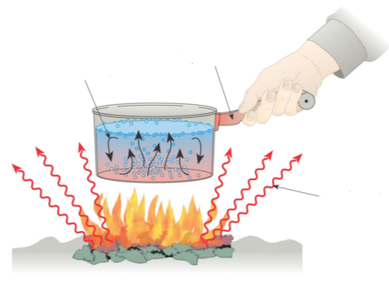

Part 5. Know that you understand what heat transfer is and how it works. For each method of heat transfer, come up with an example not shown on the website or written about on this worksheet. Write the example and draw a picture with arrows showing the direction of heat transfer.
Method of Heat Transfer | Radiation | Convection | Conduction
Example

Drawing

