NAME: __________________________________________ CLIMOGRAPH Worksheet

VOCABULARY
climograph – A graph that shows the annual (yearly) cycle of temperature and precipitation for a geographical location.
climate – The average weather conditions prevailing in an area over a long period of time.
weather - The state of the atmosphere at a place and time with regard to temperature, cloudiness, dryness, sunshine, wind, rain, etc.

DIRECTIONS: Use the following climographs to answer each of the related questions.

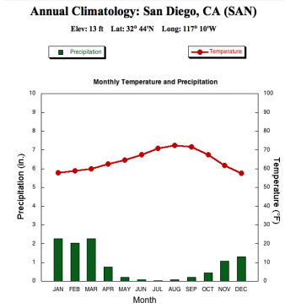
San Diego, CA
1. The data used for the climograph of San Diego, CA. was collected over how many years? ___________
2. Approximately how many inches of precipitation does San Diego get in January? _______________
3. In which month would you be least likely to need an umbrella in San Diego? _____________________
4. Approximately how many inches of precipitation fall in San Diego during an entire year? _______________
5. What is the temperature difference between the hottest and coldest months in San Diego? ___________
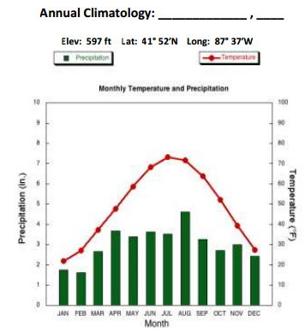
Mystery City is _______________ (Look up coordinates)
1. Which month has the highest average temperature in the “mystery city”? _____________________
2. What is the average temperature in the “mystery city” during its hottest month? _________________
3. What is the average temperature in the “mystery city” during its coldest month? ________________
4. What is the temperature difference between the hottest month and the coldest month in the “mystery city”? _____________________________________
5. What is the temperature difference between the hottest and coldest months the “mystery city”? _____________

Comparison of the Two Cities
1. Does it snow in either city? How would you be able to tell? ____________________________________________________________________________________________________________________________________________________________________________________________________
2. In your own words compare the climates of the two cities.

____________________________________________________________________________________________________________________________________________________________________________________________________
____________________________________________________________________________________________________________________________________________________________________________________________________

CREATE YOUR OWN CLIMOGRAPH! Directions: Use the statistics on precipitation and temperature in each table to create a climograph for each city in the blank graph. Look up the identity of each city using the coordinates provided. (Don’t forget to add a key to each graph)
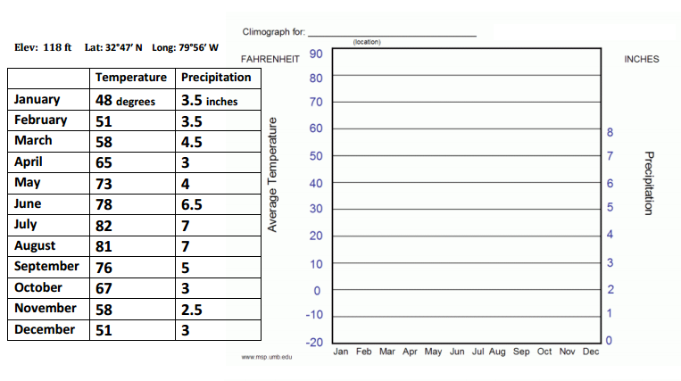
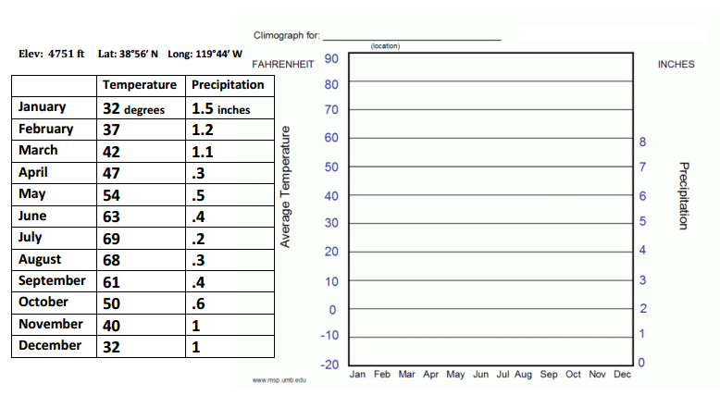
- How do the climates of the two cities compare? ________________________________________________________________________________________________________________________________________________________________________________________________________________
- What would I see in a climograph of a city with a tropical climate? ________________________________________________________________________________________________________
- What would I see in a climograph of a city with a desert climate? ________________________________________________________________________________________________________
- Do either of your cities have a tropical or desert climate? How do you know? ________________________________________________________________________________________________________

