- SpongeBob loves to garden and wants to grow lots of pink flowers for his pal Sandy. He bought a special Flower Power fertilizer to see if will help plants produce more flowers. He plants two plants of the same size in separate containers with the same amount of potting soil. He places one plant in a sunny window and waters it every day with fertilized water. He places the other plant on a shelf in a closet and waters it with plain water every other day.

- What did SpongeBob do wrong in this experiment? Explain.

- Gary is not the smartest snail in Bikini Bottom and believes he can improve his brain power by eating Super Snail Snacks. In order to test this hypothesis, he recruits SpongeBob and several snail friends to help him with the experiment. The snails ate one snack with each meal every day for three weeks. SpongeBob created a test and gave it to the snails before they started eating the snacks as well as after three weeks.

- Based on the data provided, do the Super Snail Snacks work? Explain your answer.
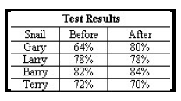
- Sponge Bob notices that his pal Gary is suffering from slimotosis, which occurs when the shell develops a nasty slime and gives off a horrible odor. His friend Patrick tells him that rubbing seaweed on the shell is the perfect cure, while Sandy says that drinking Dr. Kelp will be a better cure. Sponge Bob decides to test this cure by rubbing Gary with seaweed for 1 week and having him drink Dr. Kelp. After a week of treatment, the slime is gone and Gary’s shell smells better.

- What was the initial observation?

- What is the independent variable?

- What is the dependent variable?

- What should Sponge Bob’s conclusion be?

- Patrick believes that fish that eat food exposed to microwaves will become smarter and would be able to swim through a maze faster. He decides to perform an experiment by placing fish food in a microwave for 20 seconds. He has the fish swim through a maze and records the time it takes for each one to make it to the end. He feeds the special food to 10 fish and gives regular food to 10 others. After 1 week, he has the fish swim through the maze again and records the times for each.
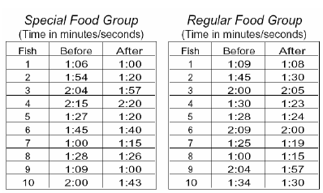
- What was Patrick’s hypothesis?

- Which fish are in the control group?

- What is the independent variable?

- What is the dependent variable?

- Look at the results in the charts. What should Patrick’s conclusion be?

- Mr. Krabs created a secret ingredient for a breath mint that he thinks will “cure” the bad breath people get from eating crabby patties at the Krusty Krab. He asked 100 customers with a history of bad breath to try his new breath mint. He had fifty customers (Group A) eat a breath mint after they finished eating a crabby patty. The other fifty (Group B) also received a breath mint after they finished the sandwich, however, it was just a regular breath mint and did not have the secret ingredient. Both groups were told that they were getting the breath mint that would cure their bad breath. Two hours after eating the crabby patties, thirty customers in Group A and ten customers in Group B reported having better breath than they normally had after eating crabby patties.

- Which people are in the control group?
- What is the independent variable?

- What is the dependent variable?

- What should Mr. Krabs’ conclusion be?

- Why do you think 10 people in group B reported fresher breath?

- Patrick and SpongeBob love to blow bubbles! Patrick found some Super Bubble Soap at Sail-Mart. The ads claim that Super Bubble Soap will produce bubbles that are twice as big as bubbles made with regular bubble soap. Patrick and SpongeBob made up two samples of bubble solution. One sample was made with 5 oz. of Super Bubble Soap and 5 oz. of water, while the other was made with the same amount of water and 5 oz. of regular bubble soap. Patrick and SpongeBob used their favorite bubble wands to blow 10 different bubbles and did their best to measure the diameter of each one. The results are shown in the chart

- What did the Super Bubble ads claim?

- What is the independent variable?

- What is the dependent variable?

- Look at the results in the chart and calculate the average diameter for each bubble solution.
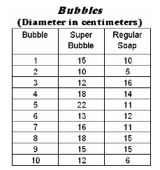

Super Bubble = ______ cm

Regular Soap = ________ cm

- What should their conclusion be?

- Are the results reliable? Why or why not?

