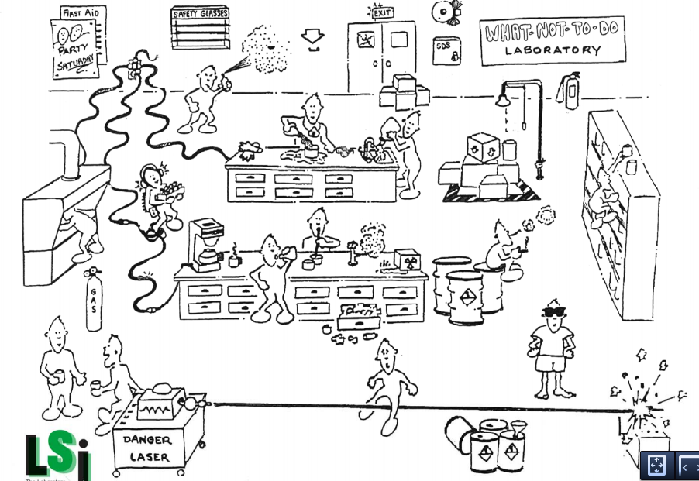

List as all the things that are going wrong in the WHAT-NOT-TO-DO Lab?

