Notes: Water Cycle Name: ______________________________
Part 1. Watch the video http://tinyurl.com/opg9nxp or scan the QR code to determine the definitions below. If you require further aid use the textbook or the internet.
Precipitation: _______________________________________________________________________________________
Forms of Precipitation: ________________________________________________________________________
Stream Flow: _______________________________________________________________________________________
Surface Run off: _____________________________________________________________________________________
Interception: _______________________________________________________________________________________
Infiltration: ________________________________________________________________________________________
Evaporation: _______________________________________________________________________________________
Transpiration: ______________________________________________________________________________________
Condensation: ______________________________________________________________________________________
Part 2. Now that you know the parts of the water cycle, illustrate the parts using the picture below. Use arrows to illustrate where the water is moving and label the arrow with the name of the transition. You must show evaporation, condensation, precipitation, run off, transpiration, and infiltration. For each term you should use a different color. I have completed one for you, it just needs to be colored.

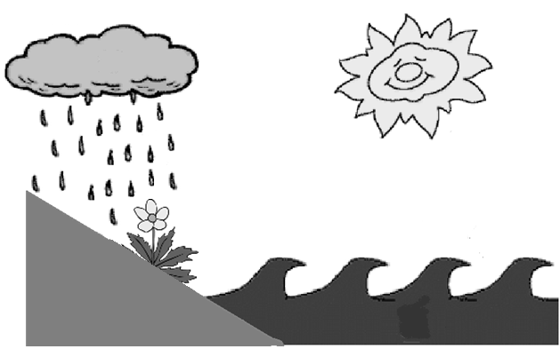
Evaporation

Part 3. Use the graph below to answer the questions.
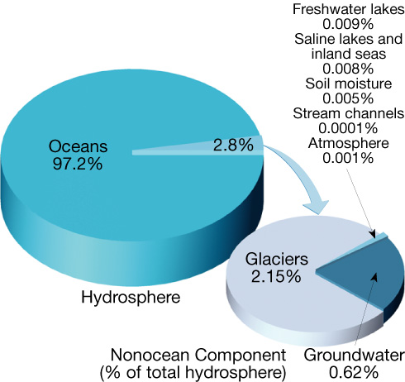

- Where is most water on the Earth found? _________________________________________________________
- Is most water saltwater or freshwater? _____________________________________
- What percentage of all water is saltwater? _________
- What percentage of all water is freshwater? _________
- Where is most freshwater found on Earth? ________________________________________________________
- Which holds less freshwater: the air or the soil? ___________

