The Ocean Floor Notes
The Blue Planet
- Nearly ________ percent of the Earth is covered by the global ocean
  - How much of the Earth is covered by land? ______
- _______________ is a science that studies all aspects of the world ocean.
  - Which hemisphere is covered by more water? _____________________________
Geography of the Oceans
- The world ocean can be divided into four main ocean basins— ________________, ______________, _____________, and _________________
- Some argue there is a fifth ocean named the ______________________
- On the map below label the four oceans
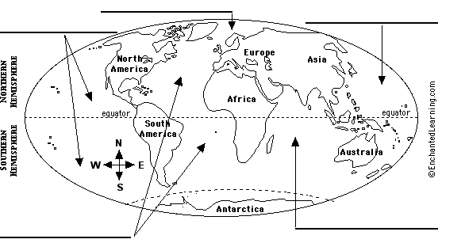
- Which ocean is the largest? _____________
- Which ocean has the greatest depth? _____________
- Place the oceans in order of size from largest to smallest:
______________ > ________________ > ______________ > ________________
Mapping the Ocean Floor
- The topography of the ocean floor is as _________________________________
- _______________ is the measurement of ocean depths and the charting of the shape or topography of the ocean floor.
- Today’s technology—particularly ___________, _____________, and _______________— allows scientists to study the ocean floor in a more efficient and precise manner than ever before.
- Sonar
  - Is an acronym for _____________________________
  - It is also known as ______________
  - Sonar works by transmitting _____________________________.
  - Label the signals below
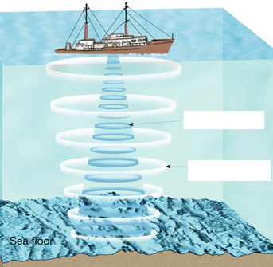
- Satellites
  - Satellites are able to measure small differences by bouncing _____________________________
  - Using this new technology, scientists have discovered that the _____________________________.
  - Differences in the height of the ocean surface are caused by _____________________________.
- Submersibles
  - Submersibles are _______________
_____________________________.
  - Today, many submersibles are ____________________________.
  - These remotely operated vehicles __________________________________________________________
Ocean Floor Features
- The ocean floor regions are ____________________, __________________, ________________.
- A ________________________ is the zone of transition between a continent and the adjacent ocean basin floor.
- In the __________________, thick layers of undisturbed sediment cover the continental margin. This region ___________________________________.
- Label the continental margin on the diagram below:
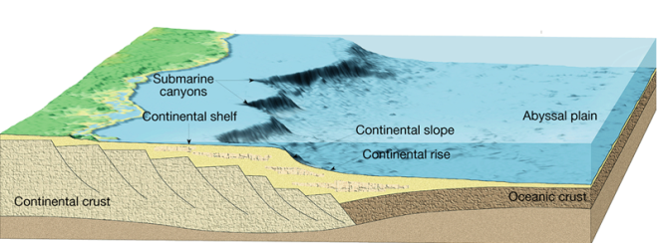

- In the __________________, oceanic crust plunges beneath continental crust. This force results in a narrow continental margin that experiences ____________________ ______________________________.
  - Why is there more activity at the Pacific Ocean continental margin vs the Atlantic?
__________________________________________________________
- A _____________________ is the gently sloping submerged surface extending from the shoreline.
- Continental shelves contain important _______________________________________________________________________.
- A _______________________is the steep gradient that leads to the deep-ocean floor and marks the seaward edge of the continental shelf.

- A __________________ is the gently sloping surface at the base of the continental slope.
- The _________________ is the area of the deep-ocean floor between the continental margin and the oceanic ridge.
- _________________ form at the sites of plate _______________ where one moving plate descends beneath another and plunges back into the mantle.
  - When one plate moves beneath another it is called? _____________
- An _________________ is a very level area of the deep-ocean floor, usually lying at the foot of the continental rise.
- The sediments that make up abyssal plains are carried there by turbidity currents or are ________________________________.
- A ________________ is an isolated volcanic peak that rises at least 1000 meters above the deep-ocean floor, and a guyot is an eroded, submerged seamount.
- A ____________________ is found near the center of most ocean basins. It is an interconnected system of underwater mountains that have developed on newly formed ocean crust.
- _____________________ is the process by which plate tectonics produces new oceanic lithosphere at ocean ridges.
- New ocean floor is formed at mid-ocean ridges as __________________________ __________________________________.
- ____________________ form along mid-ocean ridges. These are zones where ___________________________________
___________________________________
___________________________________.

In the diagram below label the features you recognize:
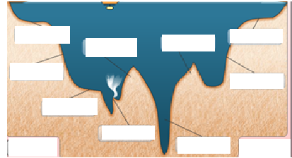
Energy Resources
- ___________________ are the main energy products currently being obtained from the ocean floor.
- Gas Hydrates
  - __________________________________________________________
  - Most oceanic gas hydrates are created when __________ break down organic matter in ocean-floor sediments.
- Sand and Gravel
  - The offshore sand-and-gravel industry is second in economic value only to __________________.
- Manganeese Nodules
  - _____________________________
- Evaporative Salts
  - When seawater evaporates, the salt increases in concentration until it can no longer remain dissolved. When the concentration becomes high enough, _________________
____________________________
  - The most economically important salt is ________________________.

