**Soil Texture Lab**

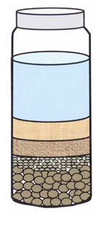

Texture refers to the size of the particles that make up the soil.  The terms sand, silt, and clay refer to relative sizes of the soil particles.  Sand, being the larger size of particles, feels gritty.  Silt, being moderate in size, has a smooth or floury texture. Clay, being the smaller size of particles, feels sticky.

In this lab, you will determine the texture of soil using two methods. In the first method, you will use water to separate the three sizes of particles and then calculate the percentage of each. Then you will use a soil texture triangle to determine the texture of the soil. The second method will involve you feeling the soil and following a flow chart to determine the texture of soil. If done correctly, the two methods should result in the same conclusion.

**Pre-lab**

1. What are the three sizes of particles in soil? Which is the largest? Which is the smallest?

_____________________________________________________________________________

1. Why would the texture of the soil matter? (Think about the Sahara desert vs Georgia)

_____________________________________________________________________________

_____________________________________________________________________________

**Lab**

1. One person in your group will go outside and collect a sample of soil. Make sure the sample is taken from a natural area and not a landscaped area. The teacher will guide you on how much soil to collect. The rest of your group will stay inside and construct their own graduated cylinder. Listen carefully on how to do this.
2. Based upon what you observe, hypothesize what type of soil you have collected? ____________
3. Bring your soil back to the classroom and split your soil sample in half. You will use half of the sample for method 1 and the other half for method 2. You will setup Method 1 today and complete it tomorrow. Method 2 will be finished today.

**Method 1**

1. Place 25 ml of soil in a 100ml graduated cylinder. Pick out any large pieces of twig, bark, or rock.

2. Add water until there is 75 ml total volume (soil + water) the cylinder.

3. Cover the cylinder with foil and secure it with a rubber band. Invert the cylinder several times until the soil is thoroughly suspended in the water. No clumps should be stuck to the bottom. Place the cylinder on the lab table in the back and leave it to settle. We will examine it tomorrow, move on to Method 2.

4. When the soil has settled out, there should be three reasonably distinct layers - sand, silt, and clay. **Draw the layers you see in the shape below and make sure to color and label the layers.**

5. Calculate the percentage of each layer by dividing the volume of the particle layer by the total volume then multiplying it by 100.

|  |  |  |  |
| --- | --- | --- | --- |
| **Particle** | **Volume (mL)** | **Total Volume (mL)** | **% of particle** |
| Sand |  |  |  |
| Silt |  |  |  |
| Clay |  |  |  |
| **Total Volume:** |  |

6. Identify the texture of your sample by using the Soil Texture Triangle and the percentages you calculated. **Highlight where your lines intersect.**

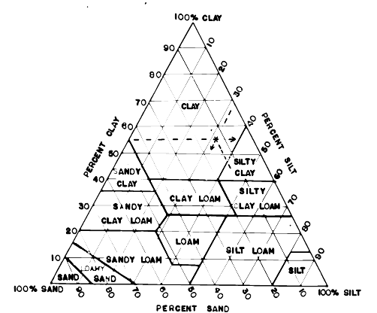

% Clay: ________________________

% Sand: _______________________

% Silt: ________________________

Method 1 Soil Texture:

___________________________________

Method 2

1. Follow the flow chart on the next page by taking 2 tsp. of soil in your hands and a few drops of water to determine the soil texture. **Color in the pathway that led to your result.**

Analysis

1. What were your results from method 1? ____________________________
2. What were your results from method 2? ____________________________
3. Do the two results agree? If not why do you think that is?

_______________________________________________________________________________________________________________________________________________________________________________________________________________________________________

1. Which method do you think is more accurate in determining the type of soil? Why?

_______________________________________________________________________________________________________________________________________________________________________________________________________________________________________

1. Research the type(s) of soil texture you have. Is this a good soil for growing crops? Why or why not? What plants can grow in this soil? (Give at least 2 types of plants)

______________________________________________________________________________________________________________________________________________________________________________________________________________________________________________________________________________

**Remember to highlight your pathway.**

Method 2 Soil Texture:

___________________________________

* When is says to form a ribbon, you are molding the clay to form the below shape:

