Characteristics of Soil
Soil is part of the _________________________
_______________________________________ Regolith is the layer of ____________________
______________________________________________________________________________ Bedrock is the layer of ____________________
In the boxes in the picture below label the bedrock and regolith.
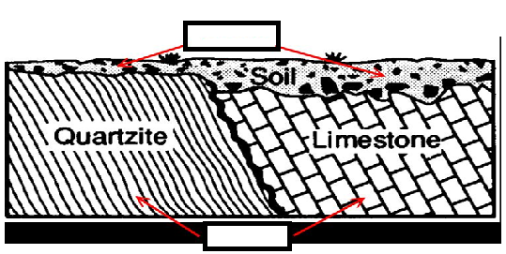
Soil Composition
Soil has four major components:
1. _____________________________________
2. _____________________________________
3. _____________________________________
4. _____________________________________
Organic matter is mostly made up of ________
Label the pie chart below showcasing the type and amount of each component of soil
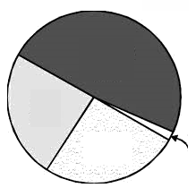
Soil Texture
Texture refers to the ______________________
_______________________________________
The three sizes are:
1. _____________________________________
2. _____________________________________
3. _____________________________________

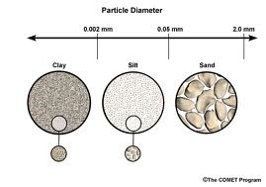

Loam (a mixture of all three sizes) is _______________________________________
Using a Soil Texture Triangle
Place arrows on the chart below indicating the directions you read each particle size

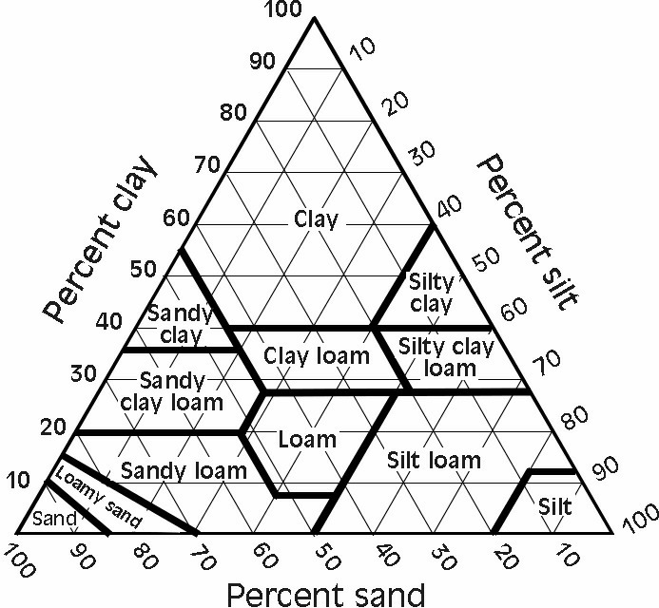

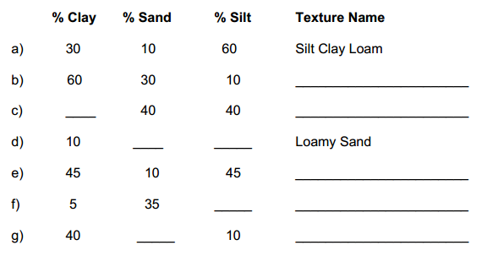
Soil Structure
Soil particles ____________________________
_______________________________________
Soil Formation
The five most important factors in soil formation are
1. _____________________ is the material ___________________________________. There are two types of soil depending upon their parent material:
- ____________________ where parent is the bedrock.
- ____________________ where parent material has been carried from elsewhere and deposited, __________.
2. _____________
- Important in all ___________________
- The longer a soil has been forming, the _______________ it becomes
3. ______________
- Greatest effect on _________________
- ______________ are best for soil formation
4. ______________
- Organisms influence the soil’s ________________________________
- Provide organic material to soil such as ________________________________
5. ________________________
- Angle
  - Steep slopes often have __________________________
  - Optimum slope is ____________________________________________________
Why would a steep slope not develop good soil? _______________________________
___________________________________
- Orientation or direction the slope is facing
  - _________________________
  - _________________________

The Soil Profile
Soil varies in ___________, ___________, ___________, and __________ at different depths
Soil horizons are _________________________
_______________________________________
A _________________ is a vertical section through all the soil horizons

Circle the three horizons below:
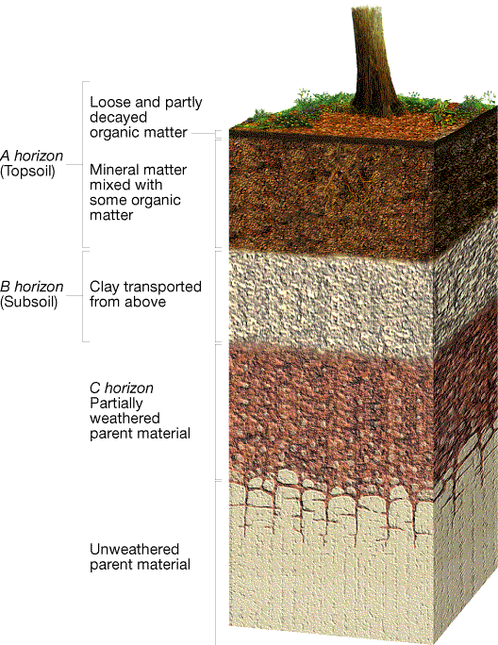
For each of the profiles below, label the horizons (A, B, C) and the parent material. Then number each profile in order of earliest to latest development.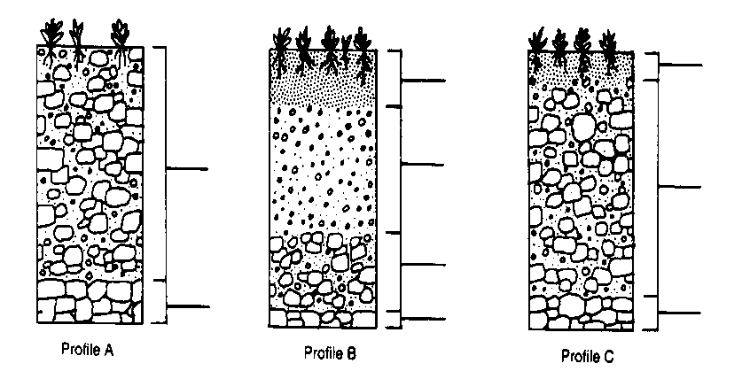
Match the graphs below to the profiles on the previous page
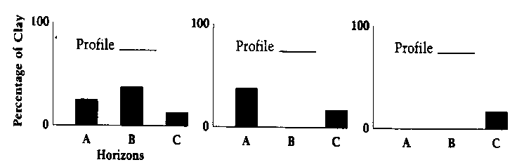
Soil Types
Three common types of soil are
- _______________
  - Best developed under _____________________________
  - Accumulation of iron oxides and aluminum-rich clays in the B horizon
- _______________
  - Accumulates __________________
  - Associated with ________________
- _______________
  - _____, _____, __________ climates
  - Intense _______________________
Soil Erosion
__________ and __________ erode soil.
Which one erodes faster? ___________
Rates of Erosion
- Depends upon ________, _________, and ________________________
- Human activities that remove vegetation such as ______________, ____________, and _______________ greatly ______________ erosion.
Sediment Deposition
- Water reservoirs fill with eroded ____ ________________________________.
- Sediments are contaminated by _____________ and _______________.
Controlling Erosion
- ________________________________
- ________________________________
- ________________________________
- ________________________________
Mass Movements
The transfer of _______ and ______ downslope due to gravity is called _______________.
Among the factors that commonly trigger mass movements are _____________________________, ______________________________, and ___________________________.
Types of Mass Movements
Geologists classify mass movements based on the kind of material that _______, ______________, and ______________________________.
- Rock falls:
______________________________________
- Slides:
____________________________________________________________________________
____________________________________________________________________________
- Slumps:
______________________________________
- Flows:
____________________________________________________________________________
____________________________________________________________________________
- Creep
______________________________________

