Water Cycle
Water constantly moves among the oceans, the atmosphere, the solid Earth, and the biosphere. This unending circulation of Earth’s water supply is
the _______________.
Processes involved in the cycle are:
*Precipitation
*Evaporation
*___________—the movement of surface water into rock or soil through cracks and pore spaces
*Runoff
* ___________-the release of water into the atmosphere from plants through the ground

Earth’s Water Balance
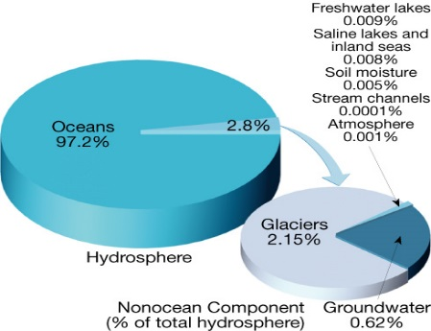
Balance in the water cycle means the ________________________________ over Earth equals the amount of water that evaporates.

________% Ocean Water (Salt)
________% Freshwater

Streamflow
The ability of a stream to erode and transport materials
depends largely on its velocity.
__________________ is the slope or steepness of a
stream channel.
Channel Characteristics:
--The ____________________ is the course the water in a stream follows.
--Shape, size, and roughness
_______________________ of a stream is the volume of water flowing past a certain point in a given unit of time
Changes from Upstream to Downstream
While gradient decreases between a stream’s headwaters and mouth, discharge ______________.
Profile:
• Cross-sectional view of a stream
• From head (source) to mouth
- Profile is a smooth curve
- Gradient__________________ from the head to the mouth
A___________________ is a stream that empties into another stream
3 Factors that increase downstream
- Velocity
- Discharge
- ________________
Factors that decrease downstream include:
- Gradient, or Slope
- Channel _____________________
Base Level- lowest point to which a stream can erode
Two General Types: 1. ________________- Sea Level 2.________________- or Local
A stream in a broad, flat-bottomed valley that is near its base level often develops a course with many bends called ________
Erosion:
Streams generally_________________ their channels, lifting loose particles by abrasion, grinding, and by dissolving soluble material.
Deposition:
- A stream’s _____________ is solid material too large to carry in suspension.
- The _______________ of a stream is the maximum load it can carry.
- Deposition occurs as streamflow drops below the critical settling velocity of a certain particle size. The deposits are called _______________
- _______________ are an accumulation of sediment formed where a stream enters a lake or ocean
- A ________________________ parallels a stream and helps to contain its waters, except during flood stage
Narrow Stream Valleys
A narrow _______________ valley shows that the stream’s primary work has been down cutting toward base level.
Two Features often include: 1. Rapids 2. _________________
Wide Stream Valleys-Stream is near base level.
- Downward erosion is less dominant.
- Stream energy is directed from side to side
The ____________ is the flat, low-lying portion of a stream valley subject to periodic flooding.
Wide Valleys
Features often include: Meanders, _____________ and Oxbow Lakes
Floods and Flood Control
A _________________ occurs when the discharge of a stream becomes so great that it exceeds the capacity of its channel and overflows its banks.
Measures to control flooding include artificial levees, flood control dams, and placing limits on______________________________

Drainage Basins A _________________ is the land area that contributes water to a stream.

A___________________ is an imaginary line that separates the drainage basins of one stream from another.

