Planet Earth Video Worksheet – Shallow Seas

1. How deep are “shallow seas”? __________________________________
2. What percentage of oceans are shallow seas? __________________
3. Which have more biodiversity – shallow sea or deep ocean habitats? __________________
4. How old is the baby humpback whale? ___________________
5. How much milk does he drink per day? _____________________
6. Coral reefs contain ____________ of all marine life on our planet.
7. What adaptation do the pygmy seahorses have?

8. What are dugongs?

9. Describe how dolphins catch their prey.

10. What grows in parts of the sea that produces most of the oxygen in our atmosphere?

11. Kelp forests off the coast of California can grow by ______________ per day!
12. Sunflower starfish like to eat brittlestars and sand dollars. They use their _____________ to taste for prey.
13. Off the coast of Africa seals thrive on a diet of ________________ and ________________
14. Each squid egg capsule contains about ______________ baby squid.
15. The ragged tooth sharks grow to _______________ meters while the Great White Shark is the ________________________________________________________ on the planet.
16. Why do Great White sharks only live in cold temperate seas? _______________________
_________________________________________________________________________
17. How long are King Penguin chicks dependent on their parents? _______________________
18. Fur seals normally eat ______________________ but sometimes eat penguins.
19. Why do humpback whales travel 6000 miles each year on a round trip from the equator to the polar seas and back? ______________________________________________________

TURN OVER

On the map below, mark a coordinate for each organism’s location and place a label of the organism’s name next to your mark.
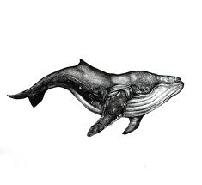
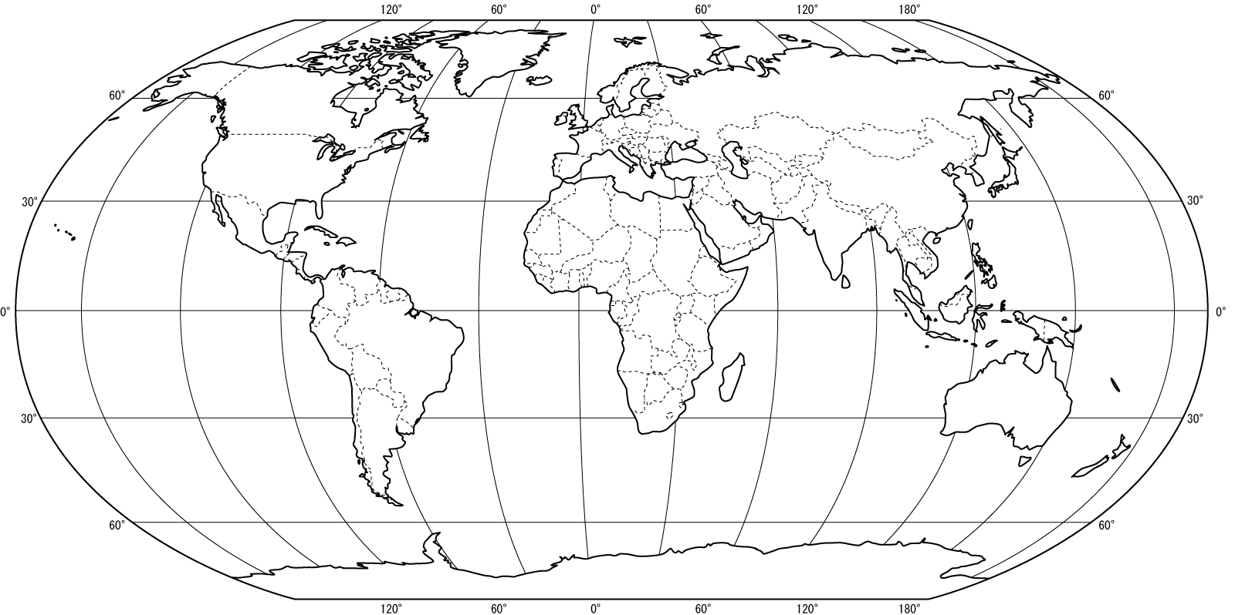
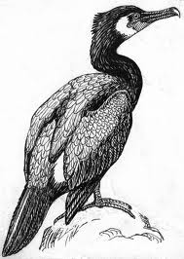
Kingdom of Bahrain,
26°S, 50°E
Aleutian Islands,
52°N and 173°W

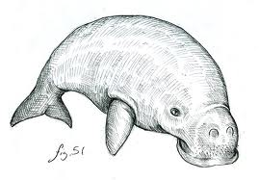
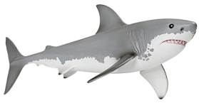
Great Barrier Reef,
18°S, 147°E
Shark Bay,
25°S, 113°E
Marion Island,
47°S, 38°E

