- Below is a profile picture of the ocean. On the diagram below mark:

- Where the water crosses the shore
- Features of the ocean that you remember

- The water in the ocean can be seperated into different zones and layers based upon changes in the water. What are some characteristics of the water that you believe change depending upon what part of the ocean you are in?

__________________________________________________________________________________

- Many different organisms are found in the ocean. Organisms in the ocean get classfied based upon similarties they have with each other. You are a scientist that is reponsible for coming up with a classification system. On the board there are six different organisms. In the boxes below place the organisms into three separate groups and then think of a third ocean organism that could fit in with the group you have created. Explain your reason for seperating the organisms into this group and give a title to the group based upon your selection criteria.

 | Group 1 | Group 2 | Group 3
Organism 1
Organism 2
Organism 3 (one you have added)
Selection criteria for group

- Based upon your criteria above, which group would an octopus fit into? ____________________
- Listen to how organisms are seperated by their lifestyles and write the three groups below and the criteria for selection.

  - _______________________: ______________________________________________________
  - _______________________: ______________________________________________________
  - _______________________: ______________________________________________________
- Categorize each organism below as plankton, nekton, benthos.

  - Bluefin Tuna: ___________________
  - Rock Oyster: ___________________
  - Northern Krill: ___________________
  - Cuttlefish: ___________________
  - Crab: ___________________

- Below is a diagram of the ocean identify where the following zones are by matching them with a letter in the diagram.

  - Intertidal Zone: ____
  - Photic Zone: ____
  - Pelagic Zone: ____
  - Benthic Zone: ____
  - Euphotic Zone: ____
  - Abyssal Plain: ____
  - Abyssal Zone: ____
  - Oceanic Zone: ____
  - Abyssal Zone: ____

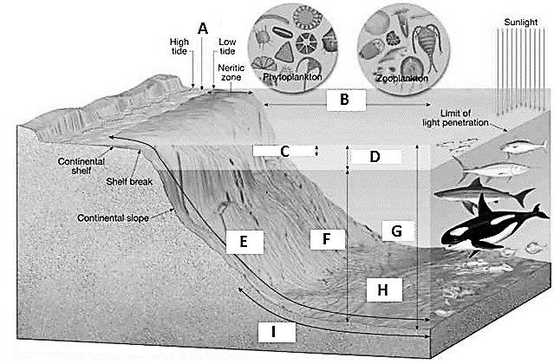
- Thinking of a bull shark and a lobster, how would you categorize each based on its lifestyle and what zone(s) would you say each lives in.

Bull shark: Lifestyle: ___________________ Habitat Zone: ___________________

Lobster: Lifestyle: ___________________ Habitat Zone: ___________________

