Name: ____________________________________________________ Date: ____________ Period: _____

Guided Notes: Groundwater

The Ground
- The ground is split into two main parts:
- _____________________________________
- _________________________________________
- _____________________________________
- _________________________________________
Circle the impermeable rock in the below picture:
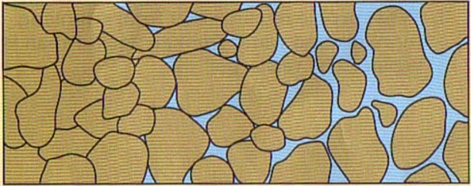
Permeable Rock or Soil
- Permeable Rock and Soil is split into two regions:
- _____________________________________
- __________________________________________________________________________________
- _____________________________________
- __________________________________________________________________________________
- Where the two zones meet is called the ______________________
Label the two zones in the picture below:
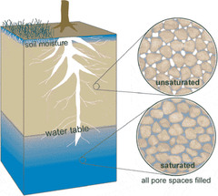
What does saturated and unsaturated mean? _______________________________________________

Zone of Saturation
- All of the water held in the ___________________
_________________________________________
- The rock or soil that holds the water in the zone of saturation is called _________________________
Why does water stay in the zone of saturation?
________________________________________________________________________________________
- _________________________________________
__________________________________ aquitard
Label the aquifer and the two zones in the picture below:
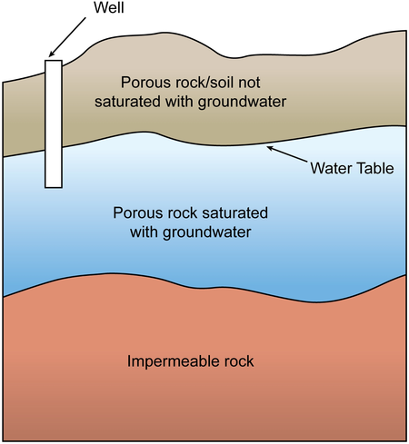
Water Movement
- The movement of water into the ground is called ______________________.
- Water ___________________________________
_________________________________________
- The amount of water that can move and stay in the ground depends upon two factors:
  - ___________________
    - _______________________________
    - Determines how much groundwater can be stored
  - ___________________
    - ____________________________________________________________________

Porosity and Permeability
Identify if each picture below has high or low porosity and permeability:
Picture | Porosity and Permeability
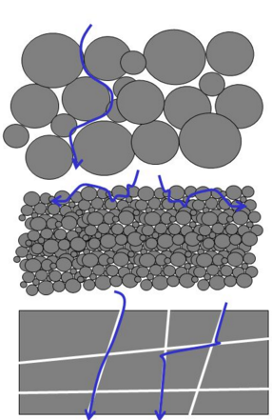
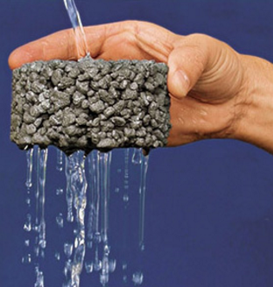
- It’s not the number of pores but the ________ of the pores that determine ___________________________
___________________________________________
Aquifers
- Aquifers are _________________________________
- The water held in aquifers is being _______________
___________________________________________
What is the largest aquifer in the US? ________________
Underground to Aboveground
- Features that can cause water from _______________ to come ___________________ are:
- _______________________ ( ______________ )
- _________________ ( _____________________ )
Springs
- A spring forms whenever the ___________________ intersects the ________________________________.
- _______________________ release ______________
that has been heated by the cooling of igneous rock
  - A ____________ is a hot spring that periodically releases ____________ and ____________.
    - Water turns into steam underground creating ______________ and causing an ___________
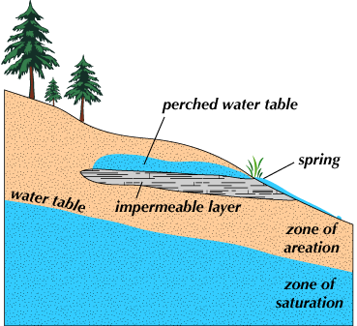
Which is the most famous geyser in the US and where is it located? _________________________________
Well
- A well is a ________ bored into the zone of ______________________
  - An artesian well is when groundwater rises due to _________________.
- Positive impact of a well
  - _____________________________________
- Negative impacts of a well
  - _____________________________________
  - _____________________________________
Draw and label a cone of depression in the box below:

Caverns
- Caverns are ____________________________ that are formed near the water table due to ________________
- _____________ dripping into the cave can form unique features in the cave depending upon how the ______________________________________
  - Stalactites: ____________________________
  - Stalagmites: ___________________________
  - Columns: _____________________________
_____________________________________
- When caverns __________ they cause _________
on the surface of the Earth
Draw and label the three features of a cavern in the box below:

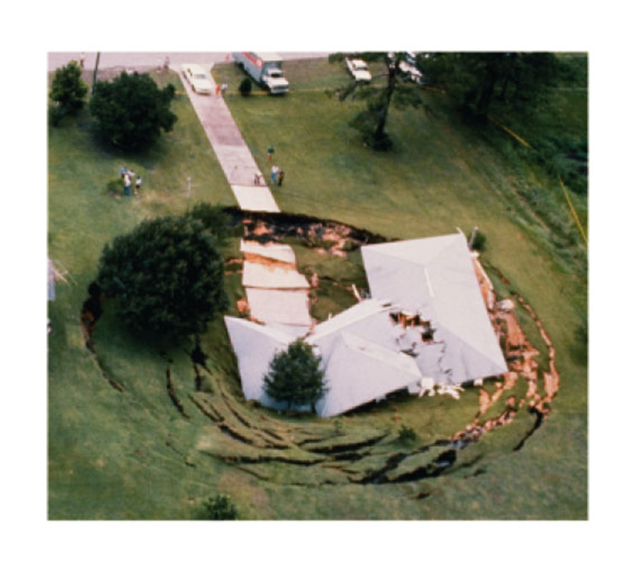
Environmental concerns
- There are three huge concerns regarding groundwater:
    - ________________________________________________________________________________________________________________________
    - ________________________________________________________________________________________________________________________
    - ________________________________________________________________________________________________________________________



