Fossil Absolute Dating
Purpose: To understand the process of using radiometric dating to determine the age of a fossil.
Pre-lab:
- Why is determine the age of a fossil important?
______________________________________________________________________________
____________________________________________________________________________________________________________________________________________________________
- How is absolute dating different from relative dating?
__________________________________________________________________________________________________________________________________________________________________________________________________________________________________________
- What are two elements in our bodies that can used for radiometric dating?
__________________________________________________________________________________________________________________________________________________________________________________________________________________________________________

Lab
Directions: Each of you has been given a role: paleontologist, chemist, or a curator. Paleontologist is responsible for keeping everyone on track and for finding and sampling the fossils. You can take samples of the fossil by scanning the qr code of the fossil. The scan will provide you with a percentage of an isotope that is given to the chemist. The chemist will compare the isotope amount to the appropriate graph to determine the age of the fossil. The curator is responsible for all note taking. The data table that they are required to fill out has been provided to them.

Post – lab:

- What two elements were used to date the fossils?
_____________________________________________________________________________
- Why could you not use the same element to date all of the fossils?
__________________________________________________________________________________________________________________________________________________________________________________________________________________________________________
- What is the age of your oldest fossil and what time period did it came from?
____________________________________________________________________________________________________________________________________________________________
- What is the age of your youngest fossil and what time period did it came from?
____________________________________________________________________________________________________________________________________________________________

- Below are sedimentary layers that have been created over millions of years. Looking at your fossil data, place you fossil in the appropriate layer by their age. You can use the fossils number to place their location in the strata.
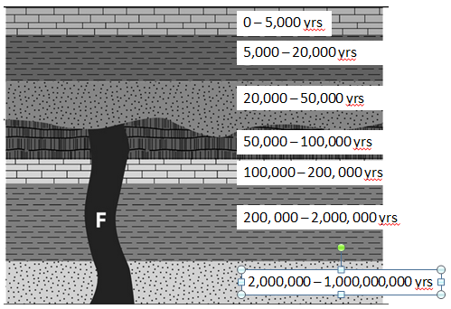
- When would you hypothesize that layer F occurred and what principle tells you that?
____________________________________________________________________________________________________________________________________________________________

- Looking at your diagram above, when were most of your fossils found?
______________________________________________________________________________
- If the half-life of C14 is 5,700 years, and a fossil been through 3 half lives of C14, how old if the fossil? What layer would you place the fossil in?
____________________________________________________________________________________________________________________________________________________________
- If the fossil in question 8 began with 80 g of C14, how much would it have after 3 half lives?
______________________________________________________________________________
- How do you think the process that you undertook in this lab is alike and different from the actual process of dating fossils?
______________________________________________________________________________________________________________________________________________________________________________________________________________________________________________________________________________________________________________________________________________________________________________________________________

